National Indian Nurse Practitioners Association of America (NINPAA) www.ninpaa.com
Volume 5
Issue 1

Executive Committee 2021-2023  Chairman Dr. Aney Paul, DNP, MSN, PNP, MPH aneypaul@yahoo.com  President Dr. Anu Varghese, MSN, FNP, DNP anumedicostar@gmail.com  Executive Vice President Prasanna Babu, MSN, FNP  Vice President Dr. Beenu Karun, MSN, DNP  Secretary Dr.Cigi Mathew, MSN, FNP, DNP Cigism@gmail.com  Joint Secretary Leena Alappat, MSN, PNP  Treasurer Beulah John, MSN, FNP  buelajohn@Aff.net  Joint Treasurer  Dr.Susamma Abraham, FNP, DNP  Committee Members  Chair, Awards/Scholarships  Dr. Alphonsa Mathew, ANP, DNP  Chair, Bylaws  Dr. Grace Mani, MSN, FNP, DNP  Chair, Editorial/Newsletter  Blessy Varghese, MSN, ANP  Chair, Research and Grant  Dr. Varsha Singh, MSN, FNP, DNP  Chair, Membership  Bridget Parappurath, MSN, FNP  Chair, Nominations  Stella Cherian MSN, FNP  Chair, Finance  Dr. Rose Puthenkulam, MSN, FNP, DNP  Chair, Professional Development/Education  Dr. Smitha Prasad MSN, ANP, DNP  Chair, Public Relations  Jessin Varghese, MSN, FNP  Chair, Social/Community Programs  Shiny Paul George, MSN, FNP  Directors-at-Large  Sunitha Menon, MSN, FNP  Dr. Maya Upadhey, MSN, FNP, DNP  Dr. Shyla Roshen, MSN, FNP, DNP  Brigit Karimkuttyil, MSN, FNP  Dr. Seline Jacob, MSN, FNP, DNP  Mercy Prakash, MSN, FNP  Auditor: Paulson Varghese MSN, FNP  Dr. Kripa Palpetta, MSN, FNP, DNP | 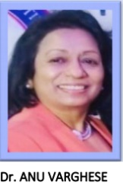  PRESIDENT’S MESSAGE  Greetings to all!!  Welcome to National Indian Nurse Practitioners Association of America (NINPAA). My sincere gratitude to the founding president Dr. Aney Paul and each of the outgoing executive members who worked tirelessly as the architects and engineers in establishing NINPAA and nurturing it to an elite organization representing NPs from twelve states.  As the president, I am humbled and honored to be surrounded by a dynamic group of talented and committed Nurse Practitioners (NPs). Our members are highly educated in specialty areas, research oriented and many of us adorn leadership positions in world renowned health care centers. Your passion and commitment to our mission inspires me and give me a positive outlook about our future activities. I welcome the new executive board, committee chairs and members for a new dawn in NINPAA’s future.  This term we have a great team of experts in ten committee as chairs and co-chairs, two auditors and we added a research committee as well as Chairman position for our organization. I am looking forward to your enhanced participation in professional and health education, leadership, research, and community services. Please continue to be active in networking through our WhatsApp group, Face book, Website and Zoom meetings. I believe that with your active participation, we can do better and reach our goal. During the COVID pandemic, members donated, volunteered, provided education and stepped up to the plate wherever needed hand in hand with the other health care providers and provided high quality health care to the American population. Thank you for your valuable contributions which makes me feel esteemed as the president of NINPAA, a truly unique organization which elicit great respect from the community.  I am excited to see what we can do next, together with the outstanding members of NINPAA, our executive members and committee chairs to reach new heights and to a new dawn. Let us move forward together keeping in mind what Mother Theresa said, “I can do things that you cannot, you can do things I cannot; Together we can do great things”.  Sincerely,  Dr. Anu Varghese DNP, MSN, FNP  NINPAA President

National Indian Nurse Practitioners Association of America (NINPAA) www.ninpaa.com

Volume 5
Issue 1
Executive Committee 2021-2023  Chairman Dr. Aney Paul, DNP, MSN, PNP, MPH aneypaul@yahoo.com  President Dr. Anu Varghese, MSN, FNP, DNP anumedicostar@gmail.com  Executive Vice President Prasanna Babu, MSN, FNP  Vice President Dr. Beenu Karun, MSN, DNP  Secretary Dr.Cigi Mathew, MSN, FNP, DNP Cigism@gmail.com  Joint Secretary Leena Alappat, MSN, PNP  Treasurer Beulah John, MSN, FNP  buelajohn@Aff.net  Joint Treasurer  Dr.Susamma Abraham, FNP, DNP  Committee Members  Chair, Awards/Scholarships  Dr. Alphonsa Mathew, ANP, DNP  Chair, Bylaws  Dr. Grace Mani, MSN, FNP, DNP  Chair, Editorial/Newsletter  Blessy Varghese, MSN, ANP  Chair, Research and Grant  Dr. Varsha Singh, MSN, FNP, DNP  Chair, Membership  Bridget Parappurath, MSN, FNP  Chair, Nominations  Stella Cherian MSN, FNP  Chair, Finance  Dr. Rose Puthenkulam, MSN, FNP, DNP  Chair, Professional Development/Education  Dr. Smitha Prasad MSN, ANP, DNP  Chair, Public Relations  Jessin Varghese, MSN, FNP  Chair, Social/Community Programs  Shiny Paul George, MSN, FNP  Directors-at-Large  Sunitha Menon, MSN, FNP  Dr. Maya Upadhey, MSN, FNP, DNP  Dr. Shyla Roshen, MSN, FNP, DNP  Brigit Karimkuttyil, MSN, FNP  Dr. Seline Jacob, MSN, FNP, DNP  Mercy Prakash, MSN, FNP  Auditor: Paulson Varghese MSN, FNP  Dr. Kripa Palpetta, MSN, FNP, DNP | CHAIRMAN’S MESSAGE  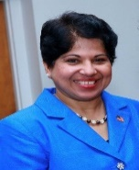 Greetings to all!!  First of all, I want to welcome and wish all the best to our new President Dr. Anu Varghese and team! I am proud to see NINPAA is getting stronger and stronger. I am grateful for the positive impacts NINPAA has made in promoting a healthy community. Let me thank all the Frontline health workers for their selfless hard work in keeping the community healthy during this pandemic. Many of our members were out there in the community as educators, volunteers, and speakers.  We have WhatsApp group where there is always a discussion, Facebook page, website, and Newsletters. We had one Souvenir so far, we will do another one next year. There is a big team working hard to make this association a great success. I am thankful to the Executive Board, Directors-at-Large, Committee Chairs and Members, and to all those working hard to make our association successful I want to thank each one of you for your support and dedication.  NINPAA continues its monthly conference calls or zoom meetings and educational workshops with different subjects, panel discussions, mentors for NP students, and helping NP students in clinical placements and jobs. I want to thank all the presenters and the participants. This year we have more committees, more activities and everyone can be part of it. Please let us know your interests, your skills and talents. Together we can make a difference.  Thank you all for giving me the opportunity to serve as Chairman of NINPAA. I am grateful for the progress NINPAA has made so far. I am thankful to the Executive Board, Directors-at-Large, Committee Members, and to all those working hard to make our association successful and request everyone please continue your support.  “If everyone moving forward together, then success take care of itself” Henry Ford  Dr. Aney Paul DNP, MSN, PNP  NINPAA Chairman

Greetings to all,
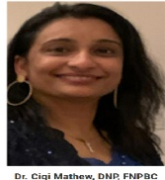
Thank you for choosing me as NINPAA secretary. It is my honor and a privilege to serve as a NINPAA secretary. My mission is to work together with all the members. We have incredibly talented group of people in the organization. As Mother Theresa said I can do things you cannot, you can do things I cannot, together we can do great things. Let us work together, we will continue the mission to unite, empower and promote the role of Nurse Practitioners. We support our members with meetings, education, discussions, teaching events, volunteering, and networking.
The COVID-19 situation has evolved further, and we are dealing with a significant global challenge. Most of the important things in the world have been accomplished without a doubt that our country and world will survive this pandemic.
I encourage you to help educate your colleagues about NINPAA and invite them to become a member of our organization. Thank you for your continued support and let us have a great year.
Sincerely,
Cigi Mathew, DNP, MSN, FNP-BC
NINPAA secretary
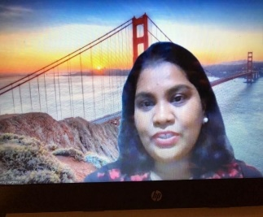
EDITOR’S CORNER
Greetings to all the wonderful NPs out there. Thank you for all the heroic work which you guys were doing to heal our country amid this pandemic which killed many of our citizens! As we pass through the difficult time in the history, we all have a long way to go. Beginning March 2020, Covid 19 changed our world upside down. Beside from the health care consequences, the impact of covid 19 was beyond our imaginations!! Schools closed, many workers were furloughed or laid off or told to work from home. Many died, many went through serious health/economic issues. Unemployment rates went high up. Slowly, we are trying to recover. The good news is that there is a vaccine on the way! Phase 1-2 trials of SARS-Cov-2 spike protein vaccine appears to be safe, and it elicited immune responses that surpassed levels in Covid 19 convalescent serum. Although, the vaccine induced immunogenicity appears promising, there is still lot more to know. The sample study sizes were small and had limited ethnic diversity. Together, we all must keep doing what we do every day! On behalf NINPA, I salute all the NP heroes who goes above and beyond!!

Sincerely,
Blessy Varghese, MS, ANP-C, NNINPAA EDITORIAL CHAIR
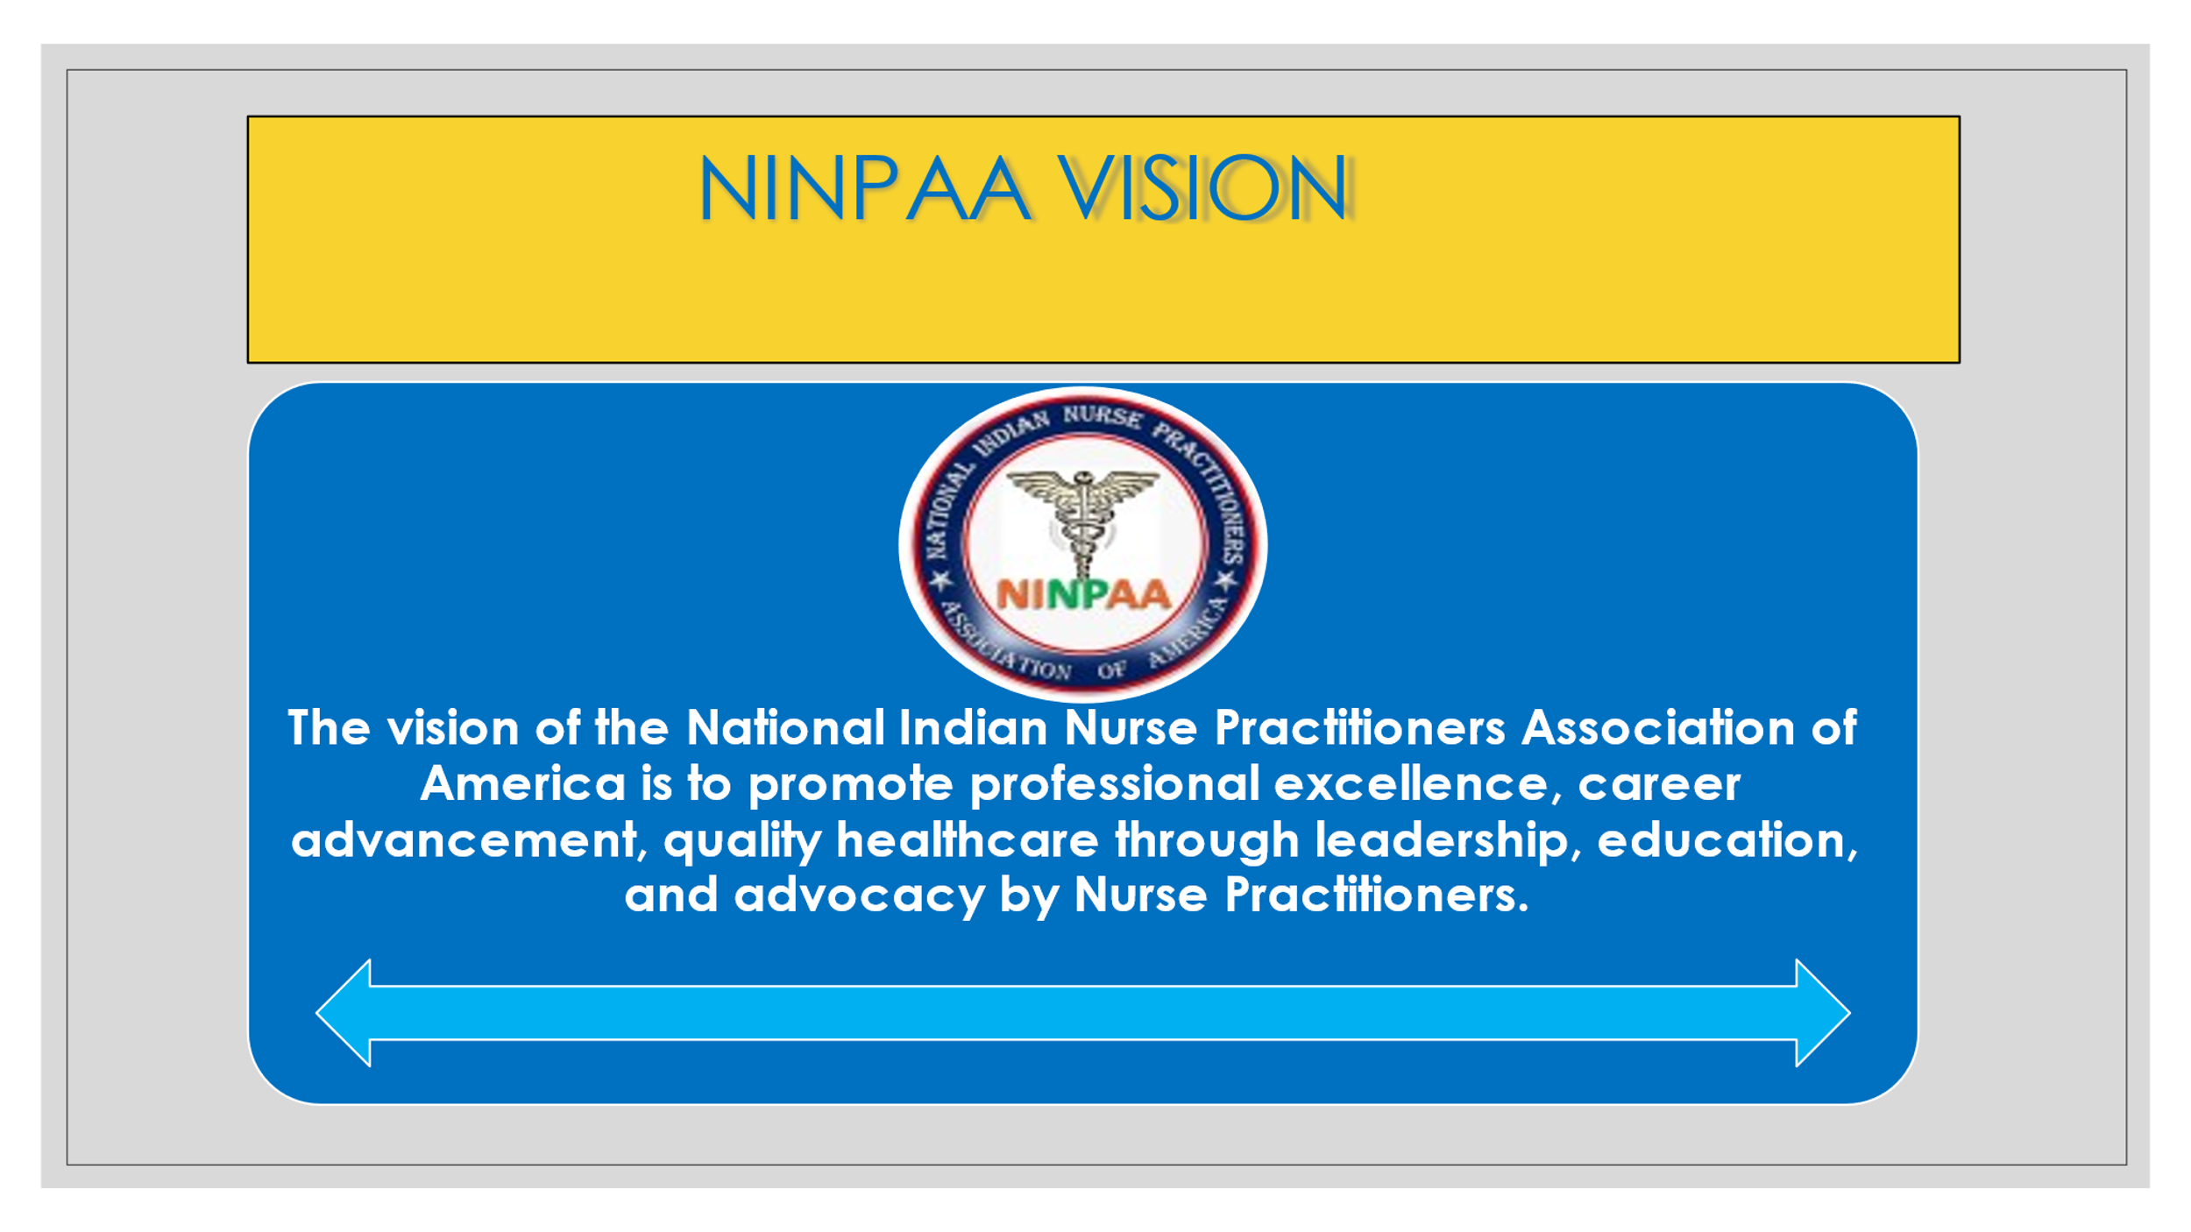
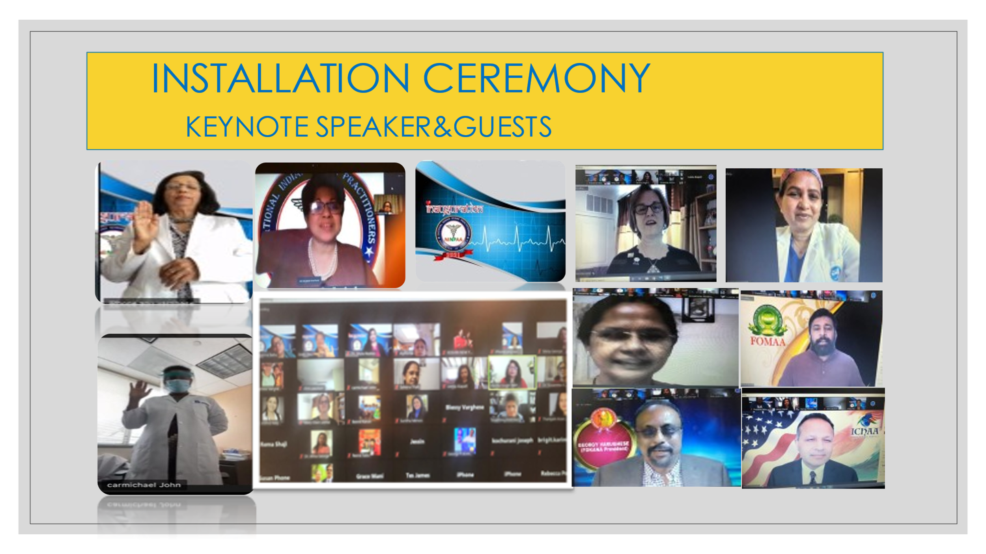
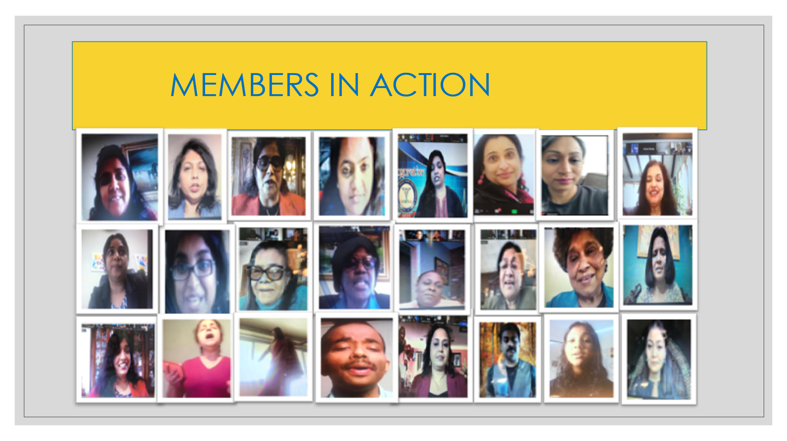
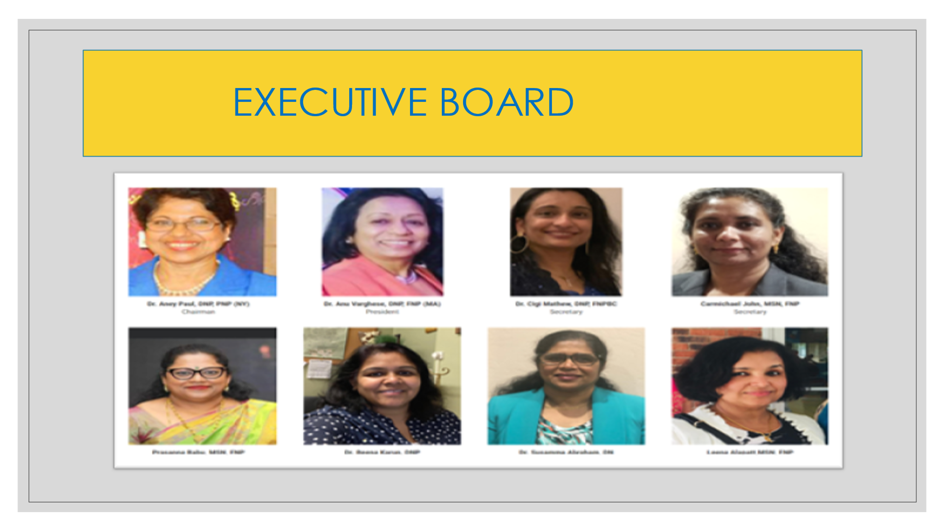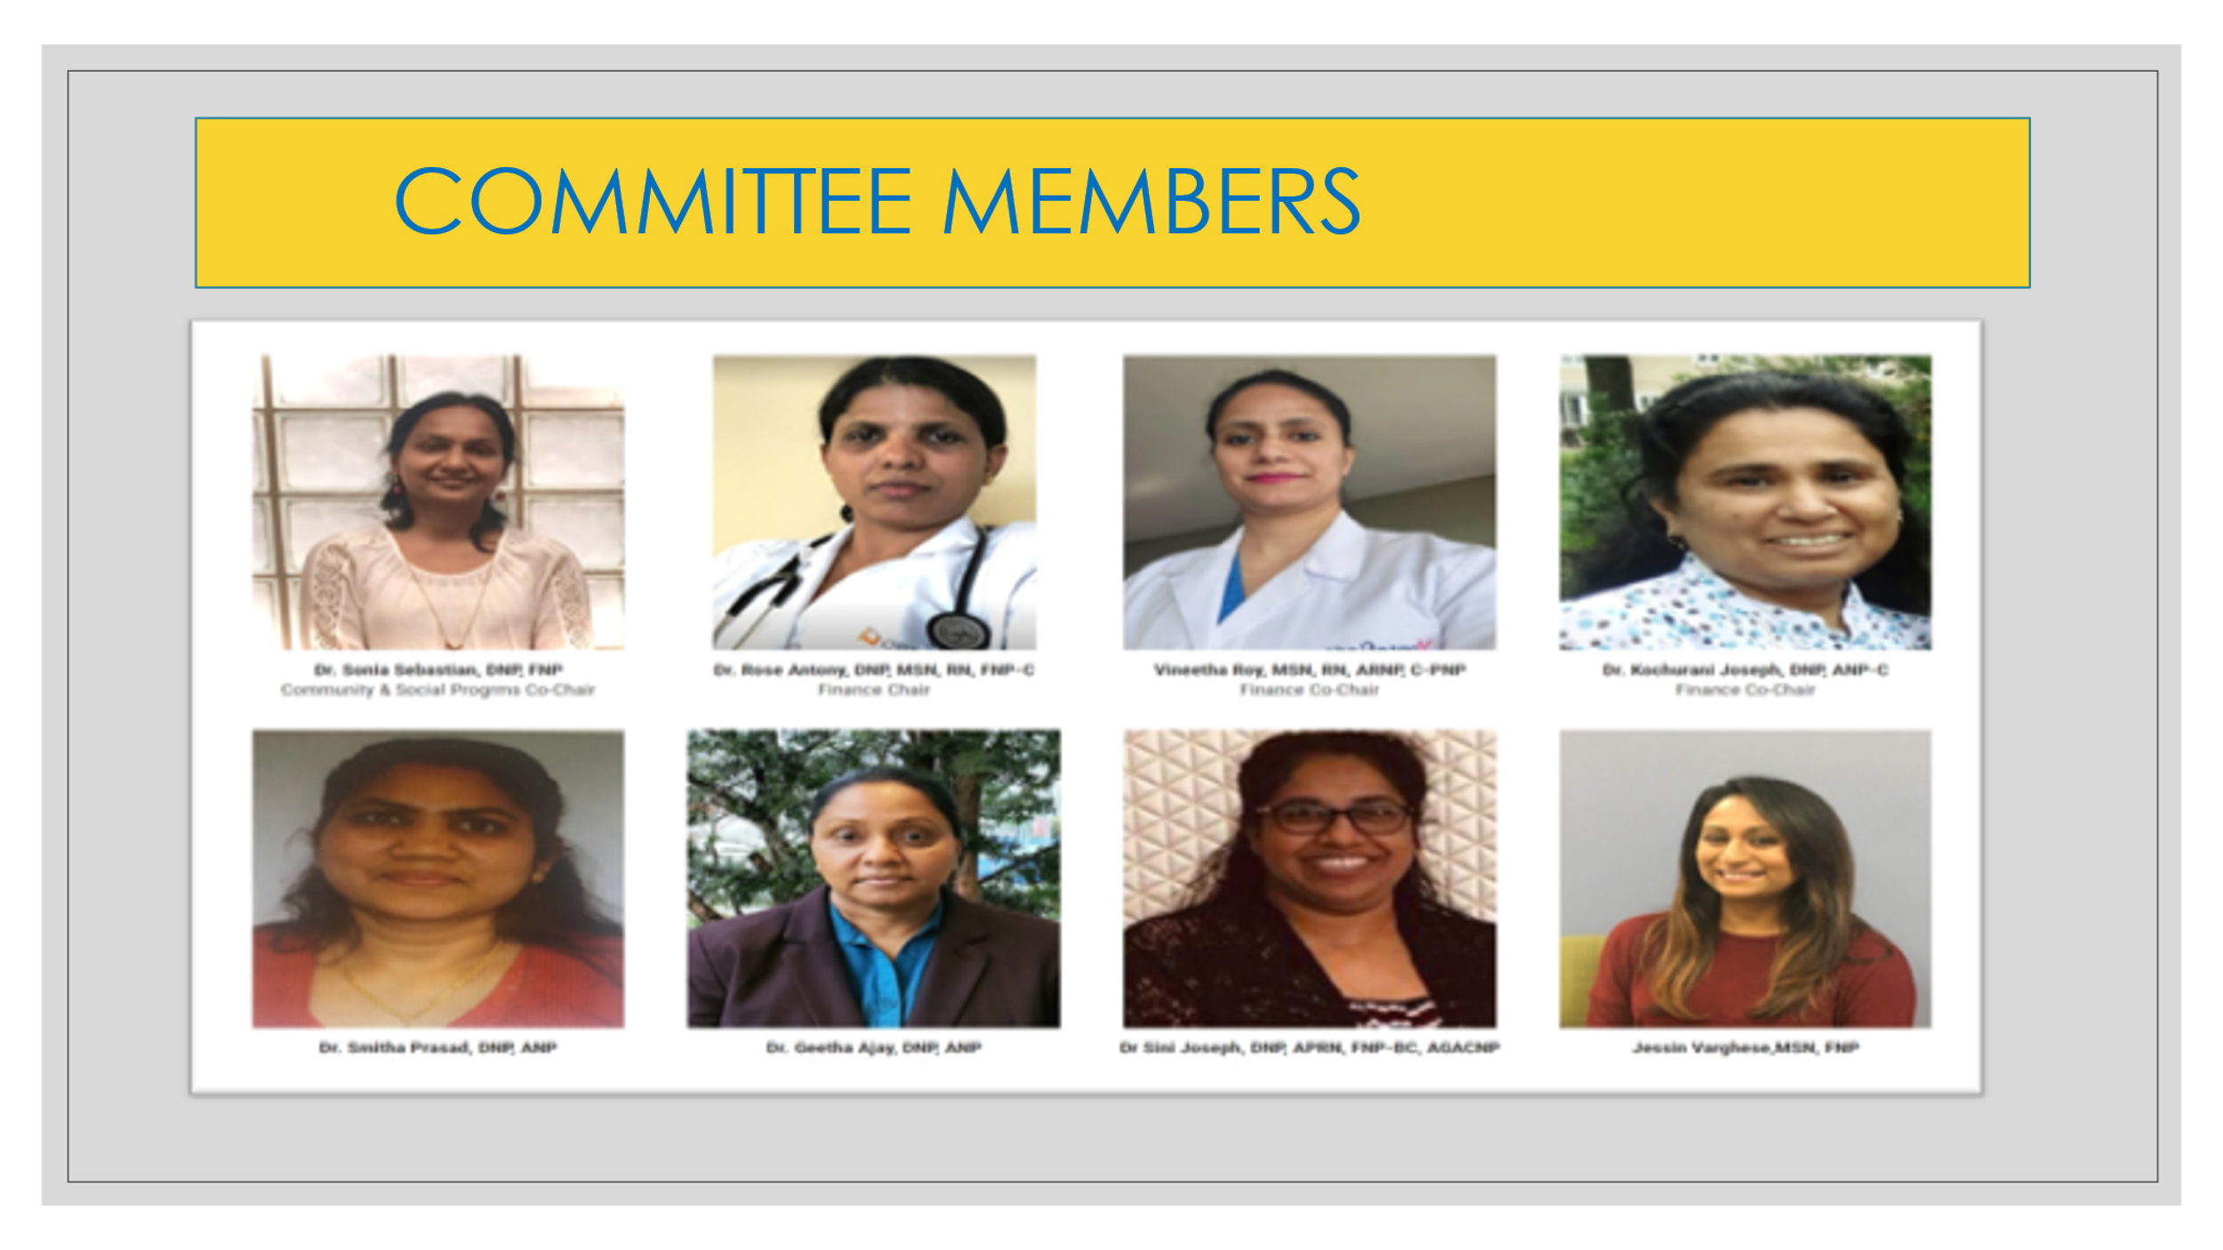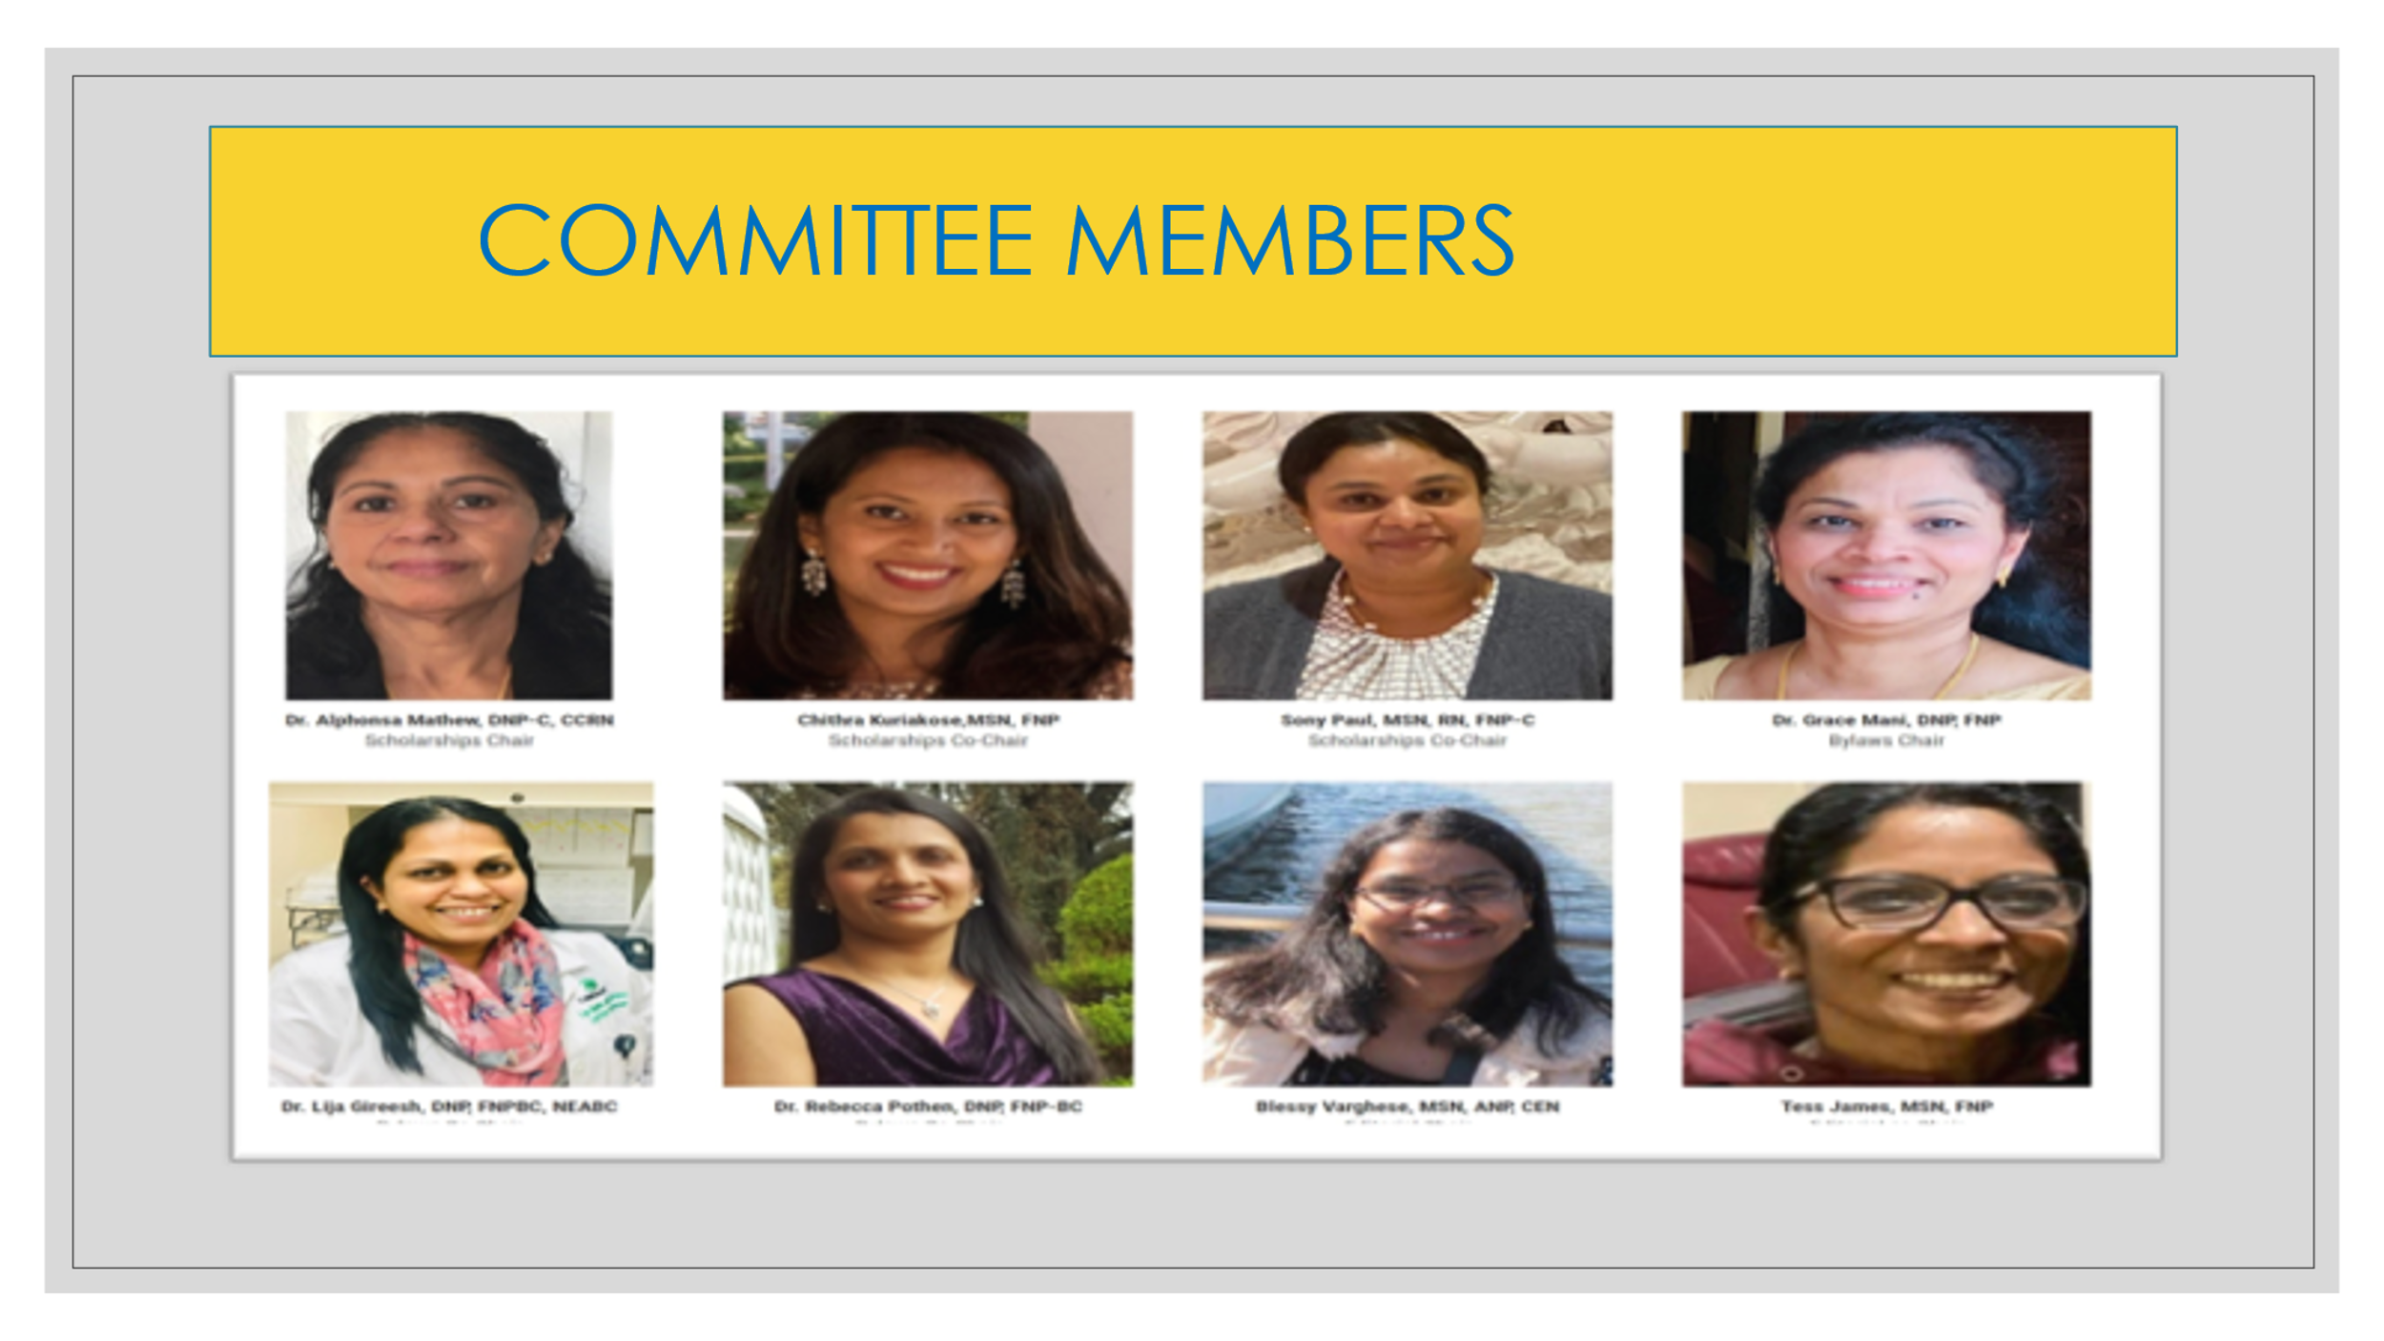
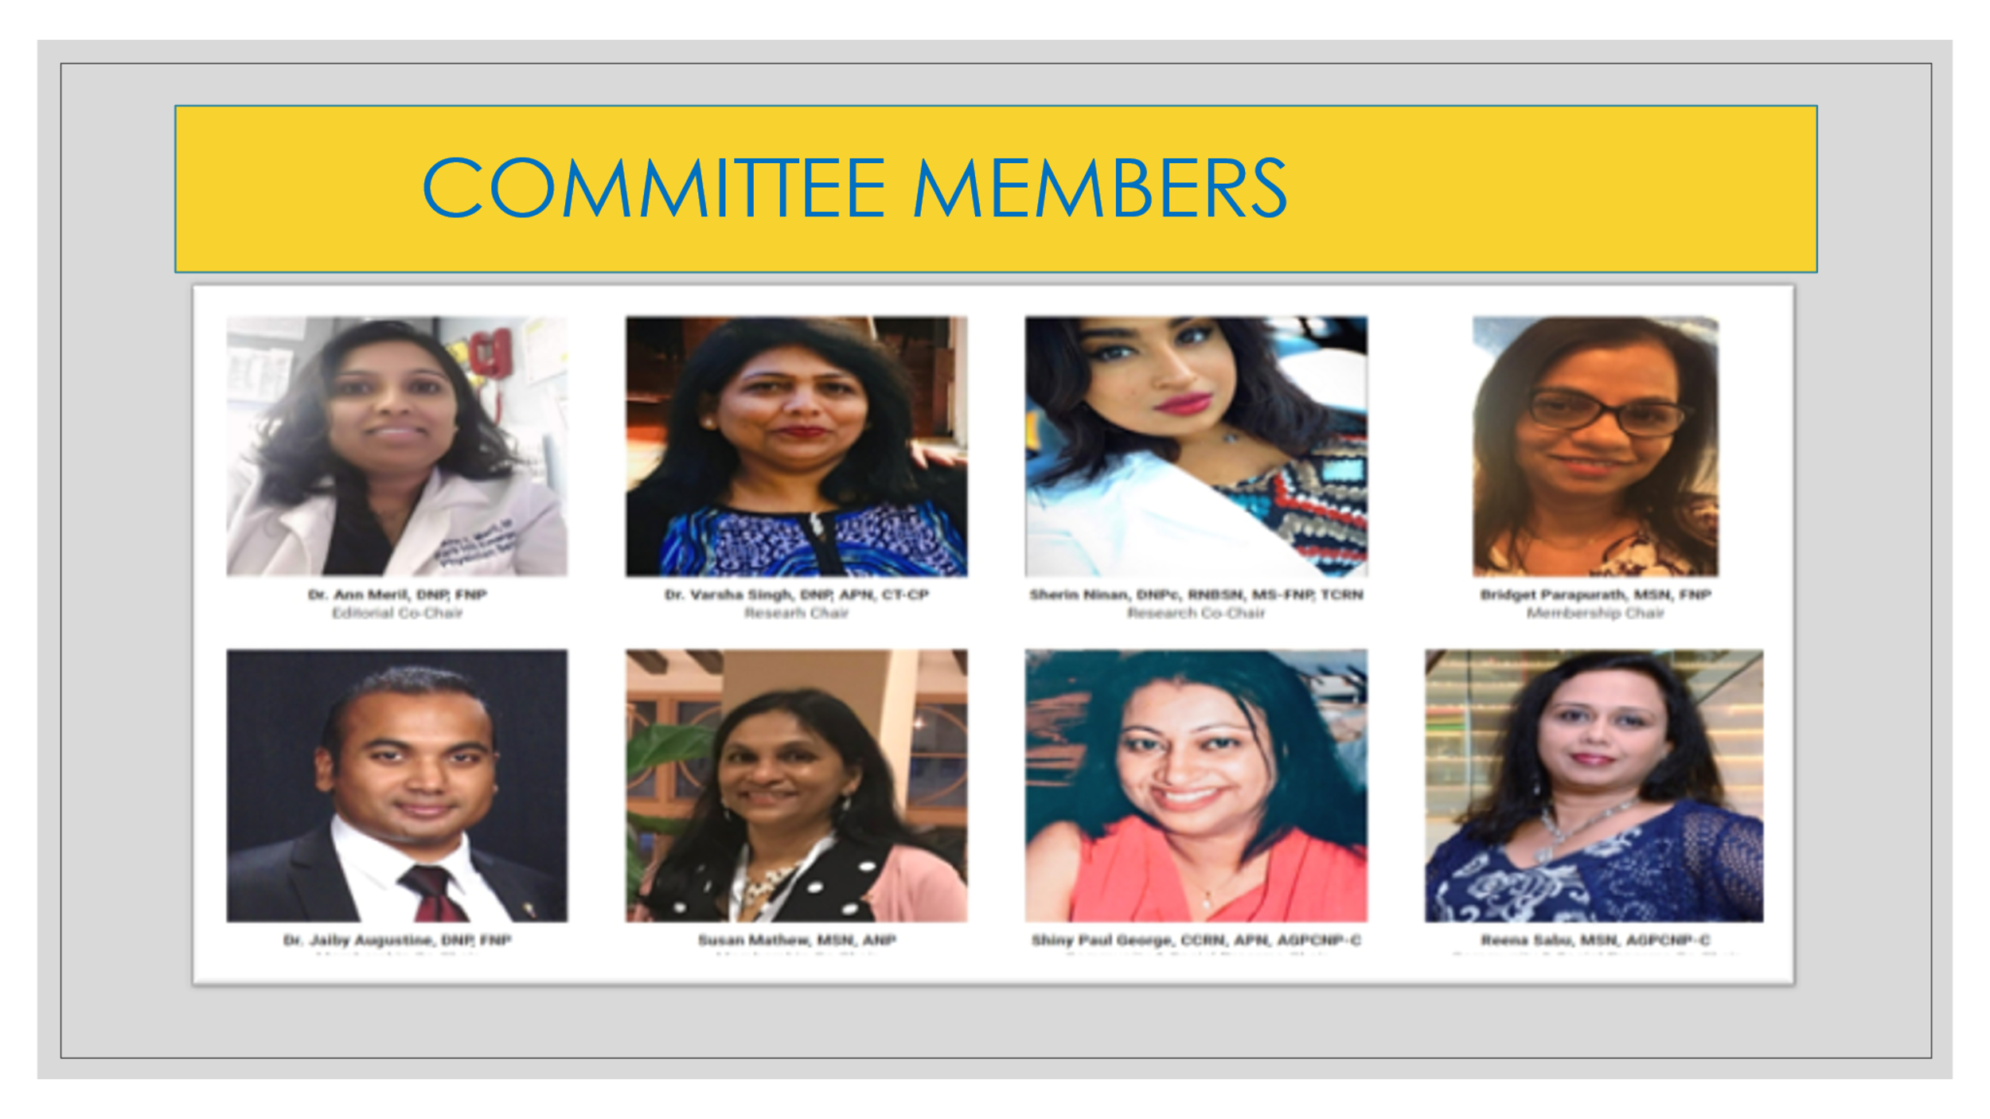
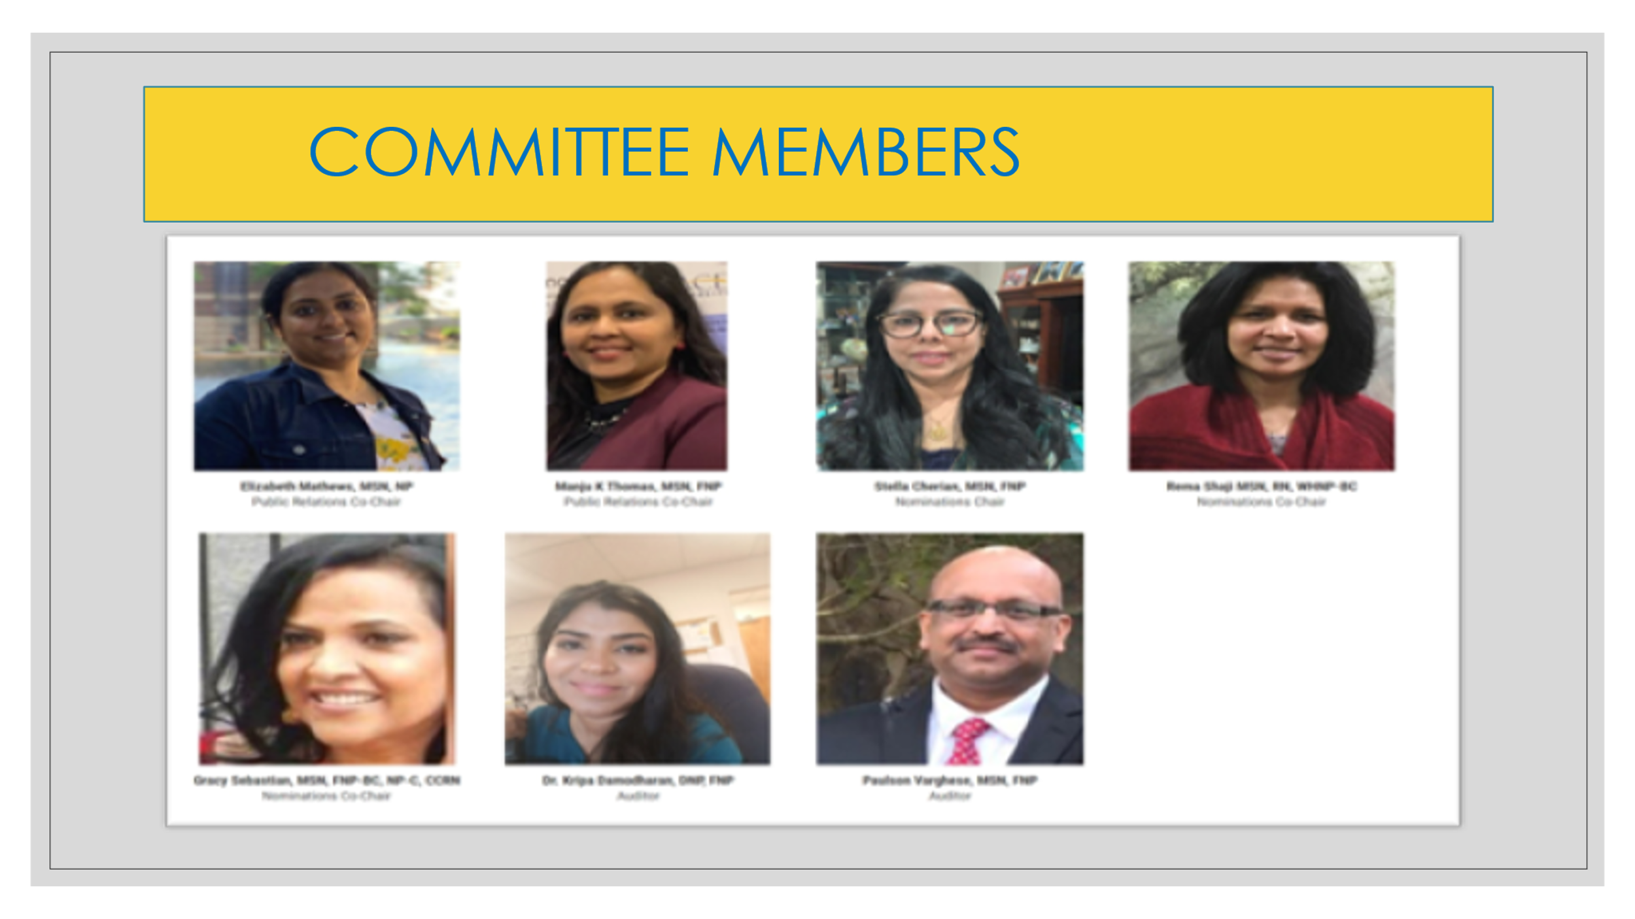
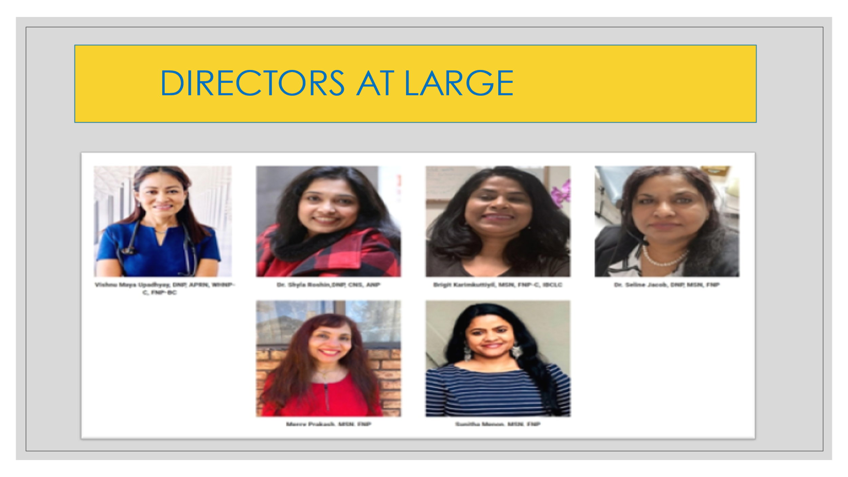

Zoom Innaguration and installation of governing body

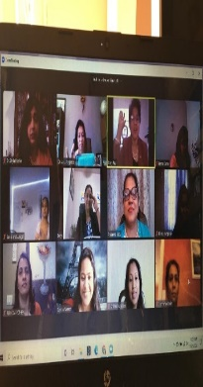

NINPAA Officers of 2021-2023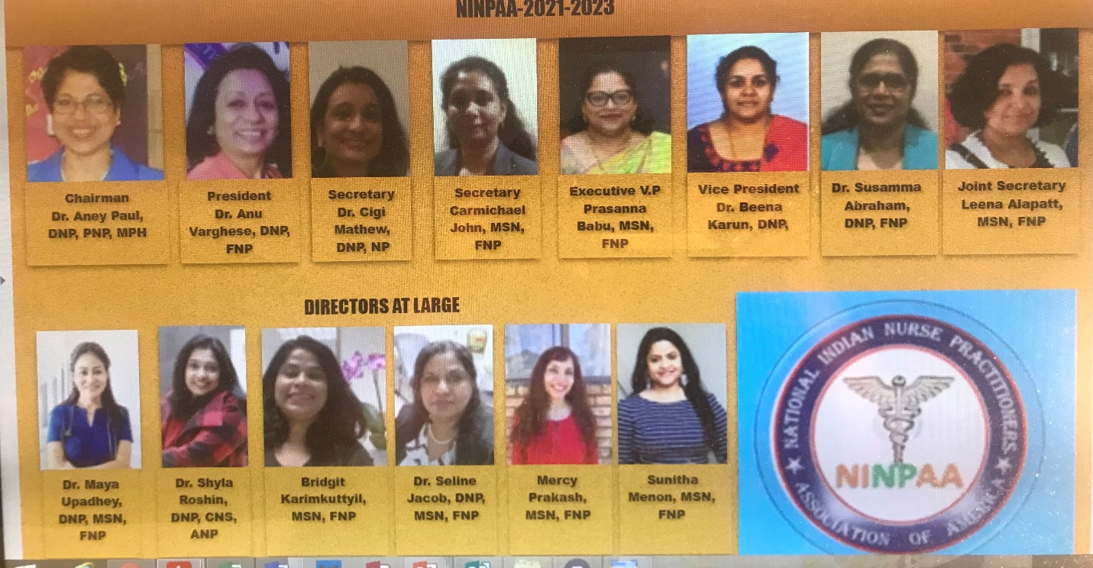

Governing Body
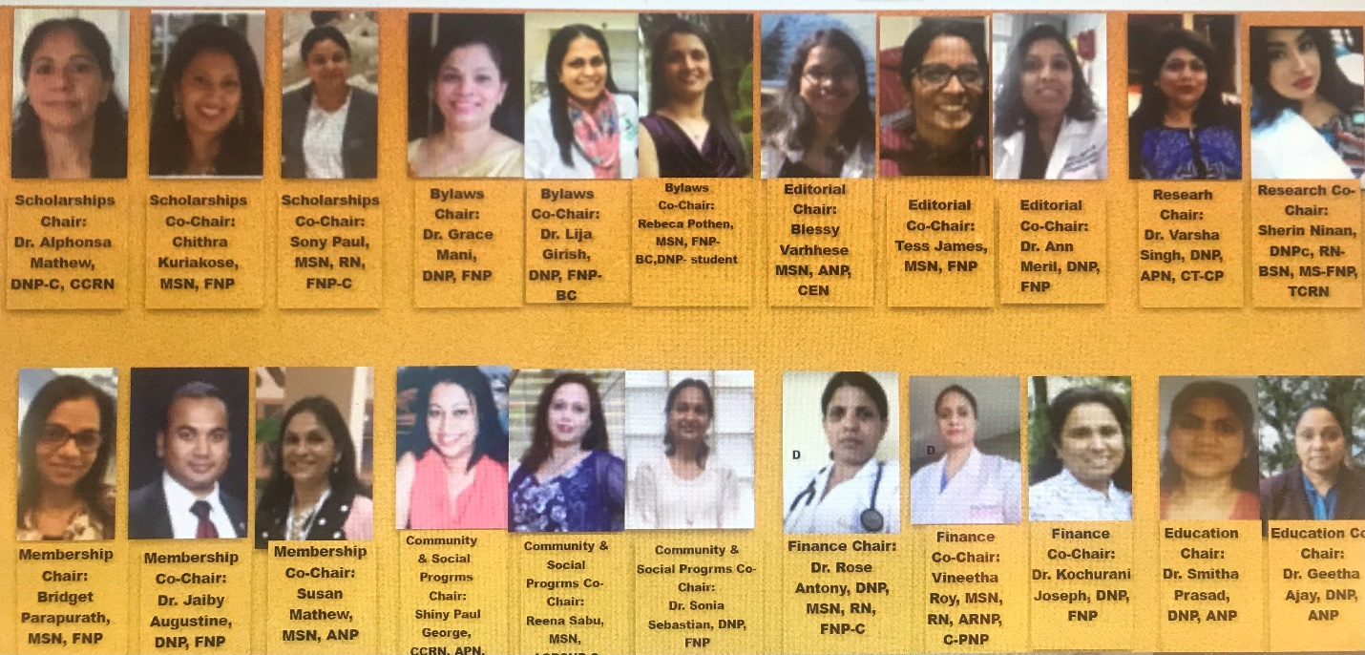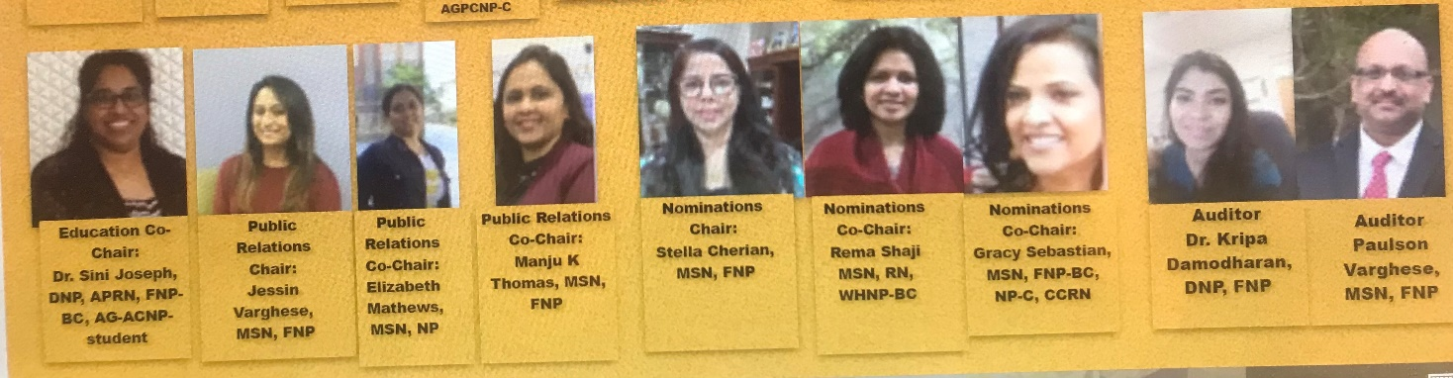

NINPPAA GOVERNING BODY

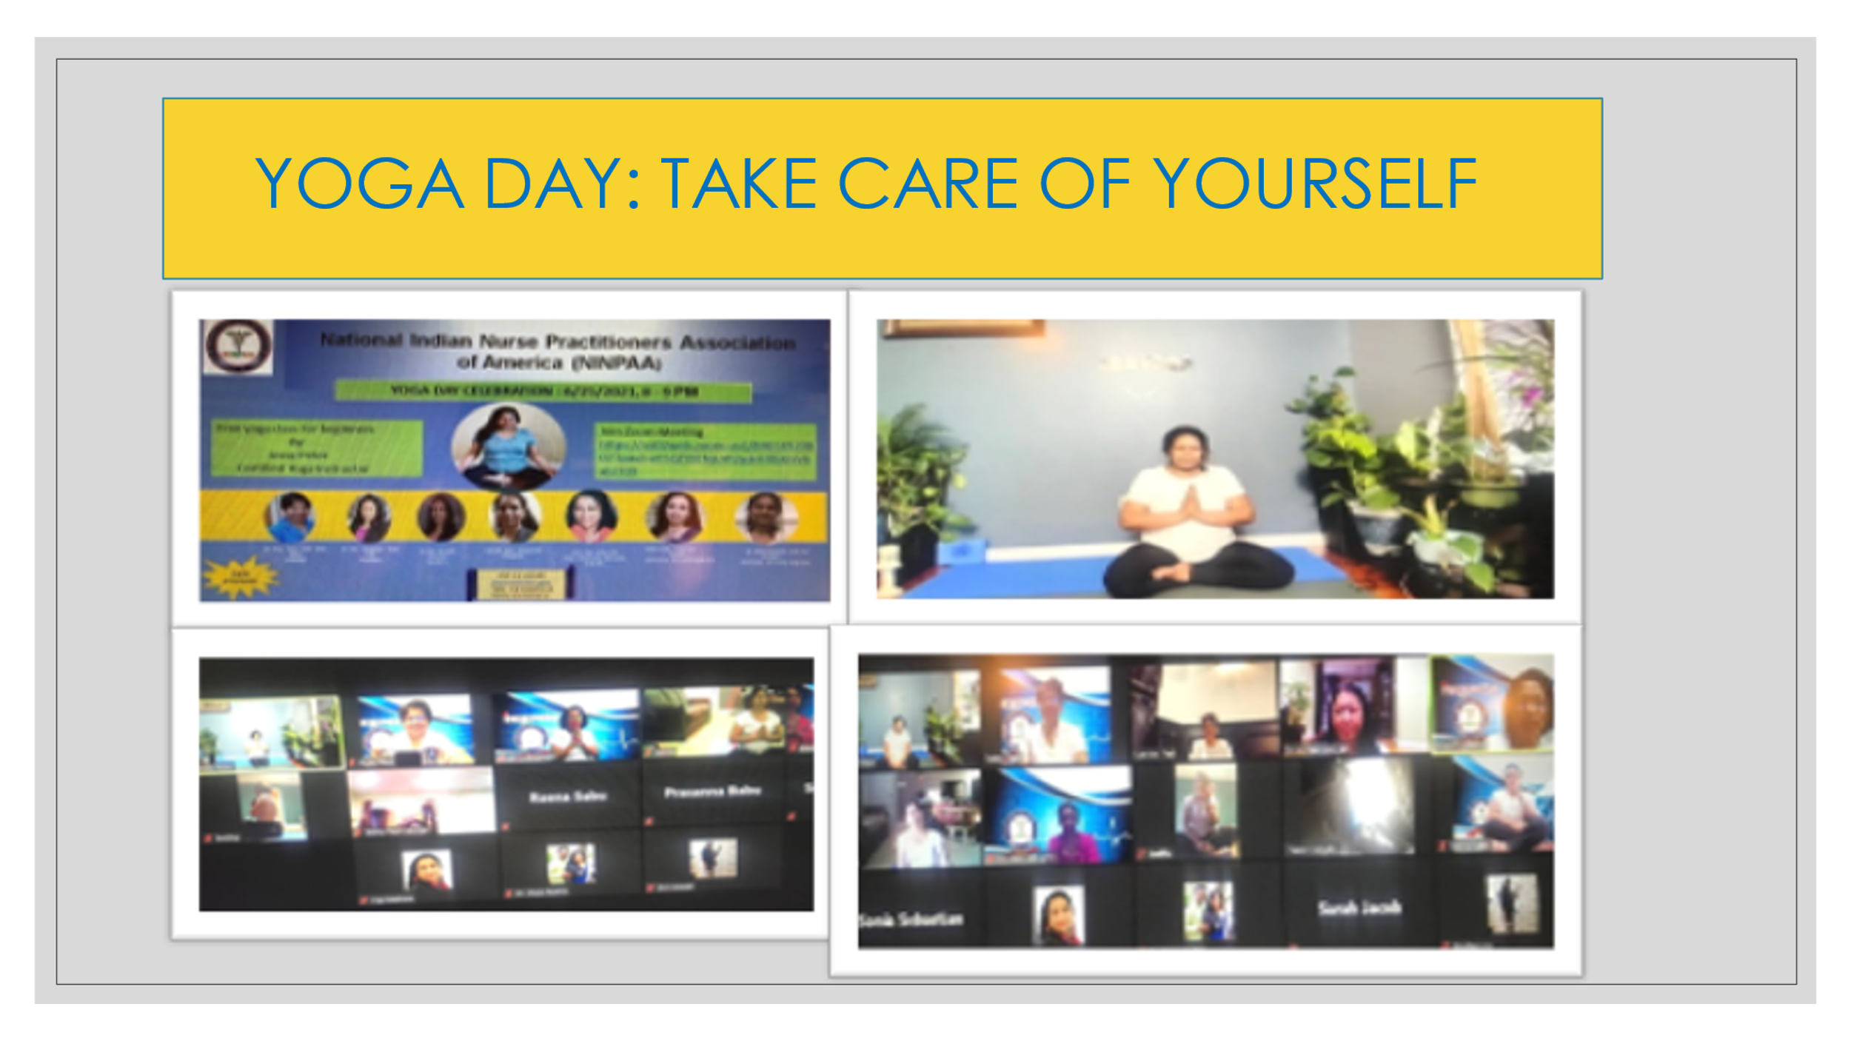
YOGA DAY: TAKE CARE OF YOURSELF
NINPAA celebrated National Yoga Day on 6/25/21. The practice of yoga has been thought to date back to pre-Vedic Indian traditions. The Term “Yoga” for western world denotes a modern form of Hatha Yoga and Yoga as an exercise! In the western world, Yoga developed into a posture based physical fitness, stress relief and relaxation technique. Yoga includes physical exercise, meditation, and spiritual wellbeing! Thanks to Certified Yoga instructor Jessy Peter who led this Yoga class!!
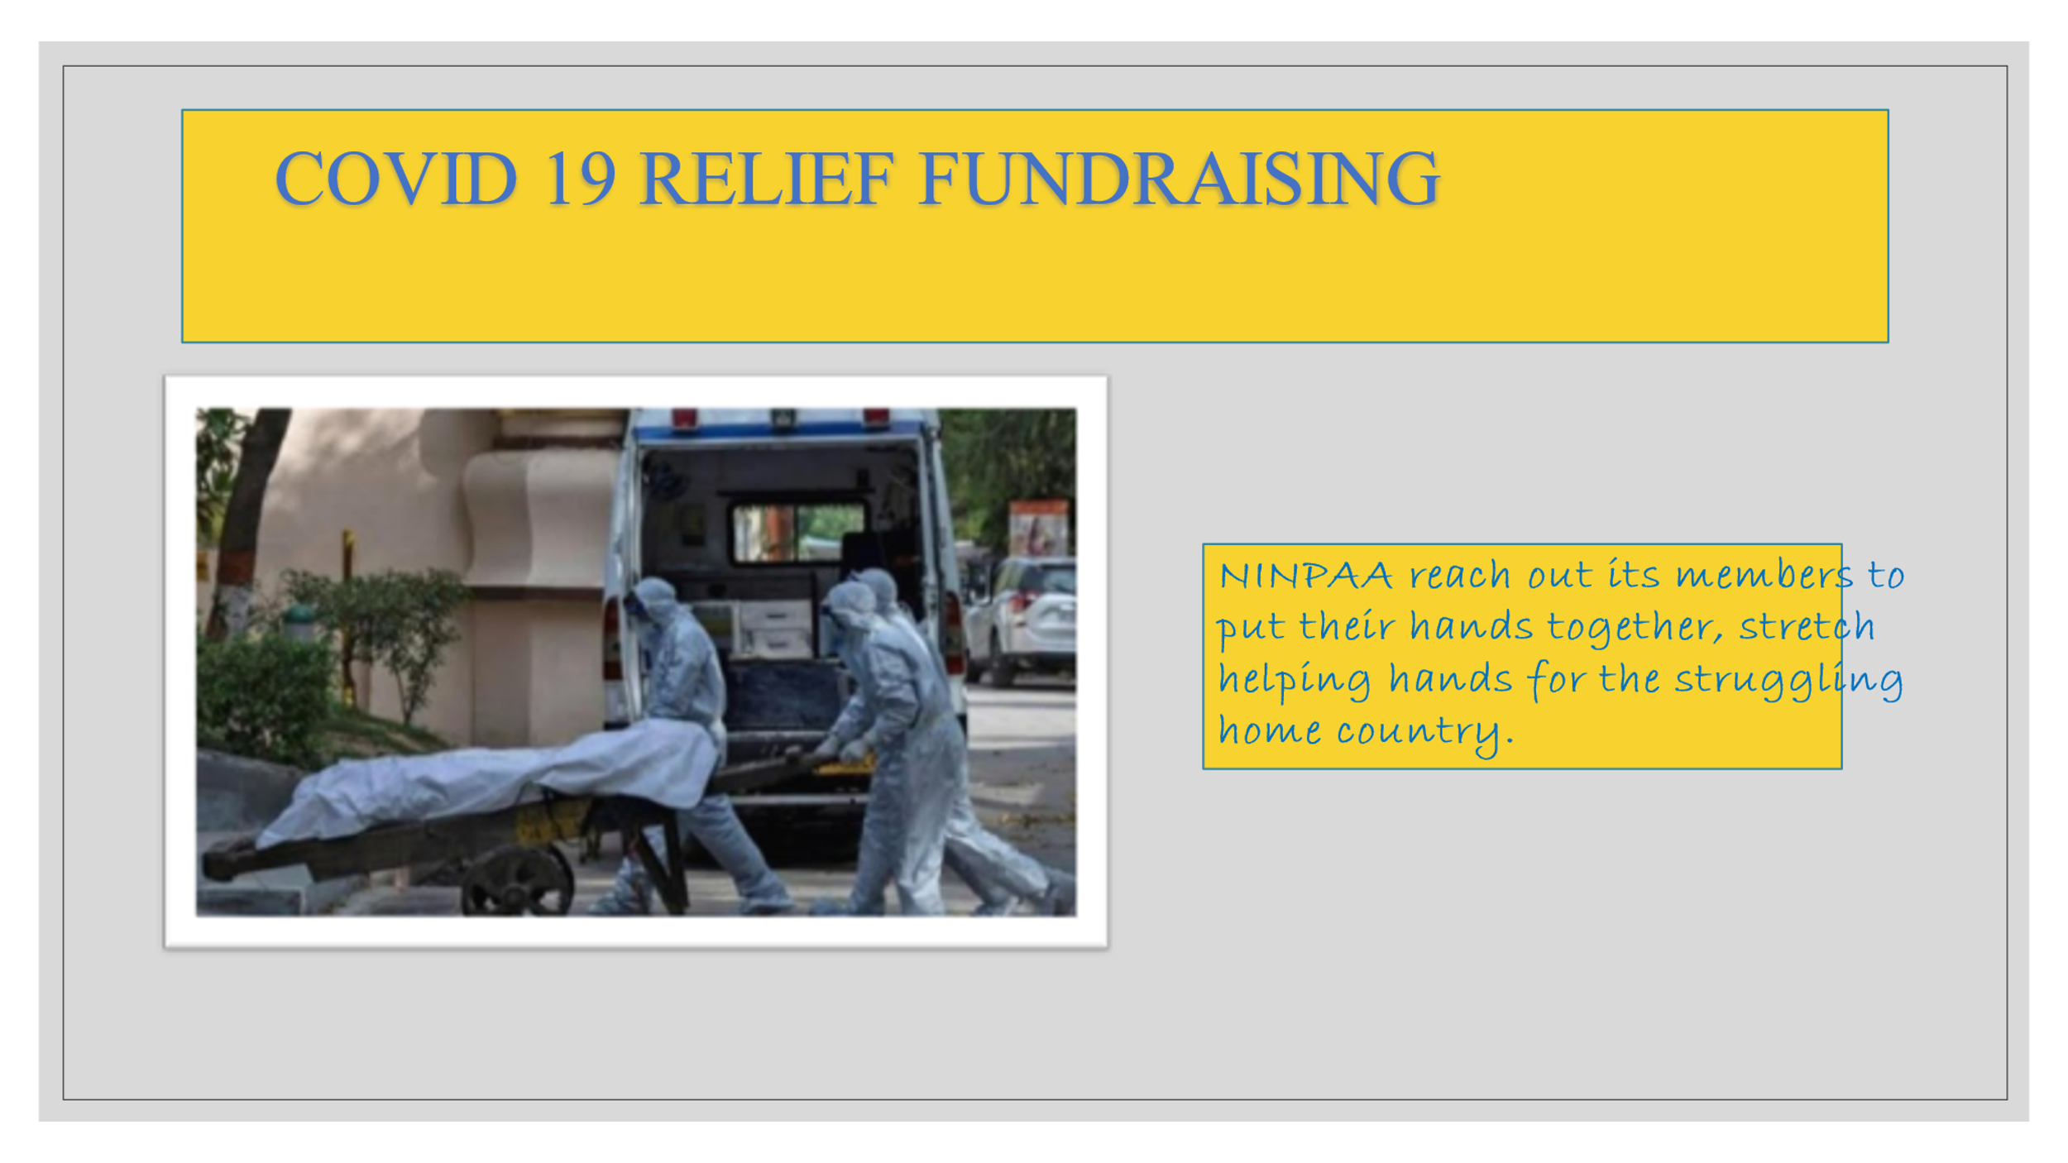
Covid 19 pandemic had a devastating impact on India. As everyone knows, a fragile and fragmented health care system is buckling, and hospitals are literally overwhelmed and had to turn away scores of patients. Hospitals are struggling without oxygen and medical supplies. NINPAA reach out its members to put their hands together stretch helping hands for the struggling home country. Thanks to Dr. Smitha Prasad for her leadership and dedication for this project.

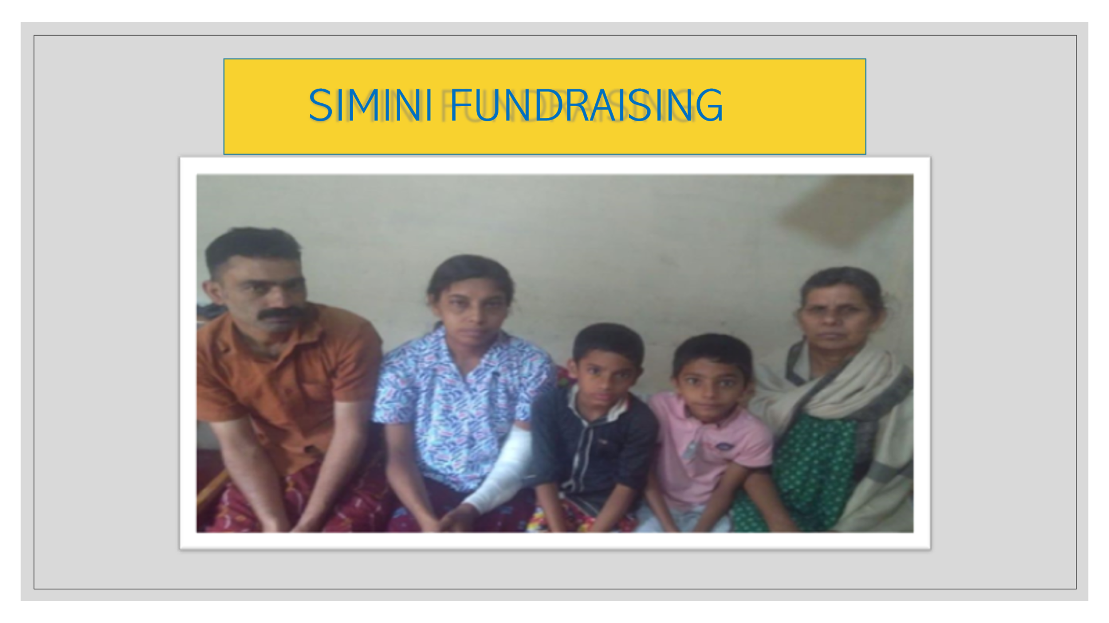
Thank you NINPAA members who graciously opened their valets to collect money for Simini, a chonic Kidney disease patient on dialysis, to buy land so that she can have a house for herself and for her family. Thanks to Dr. Aney Paul and her leadership for this endevour.
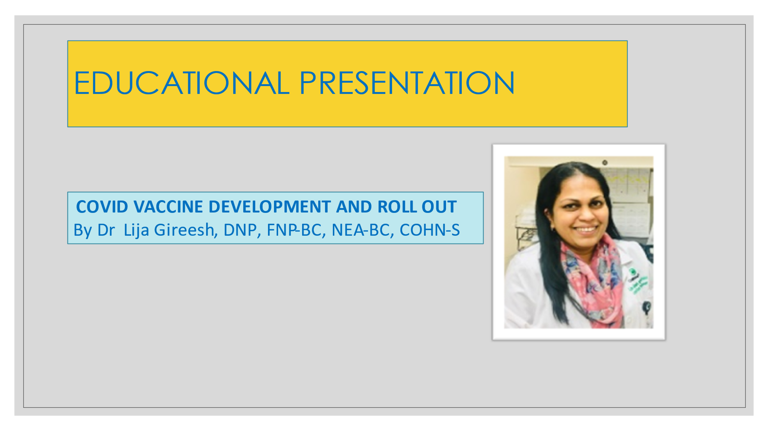
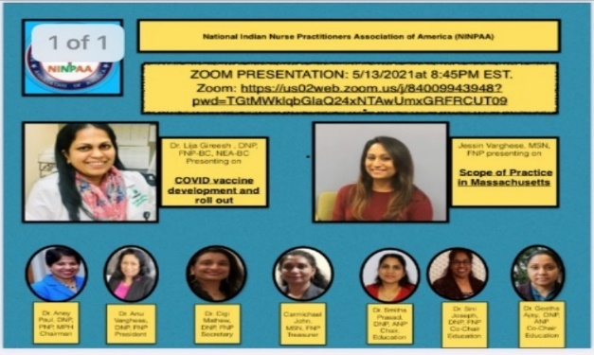
EDUCATIONAL PRESENTATIONS
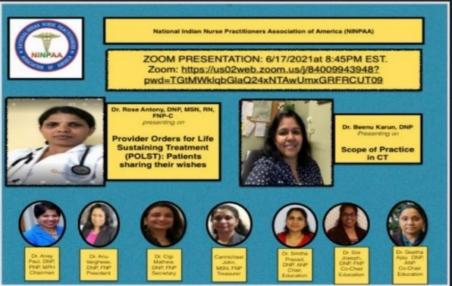

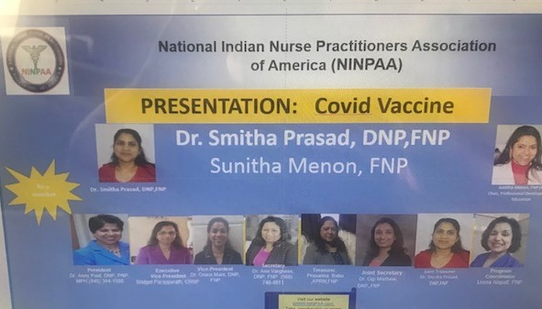
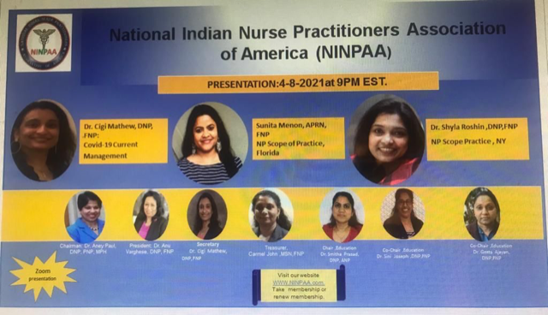
N

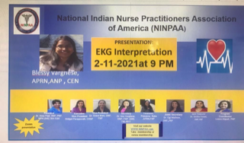
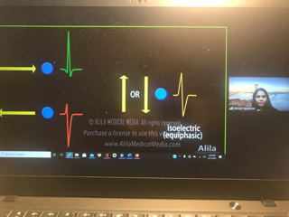

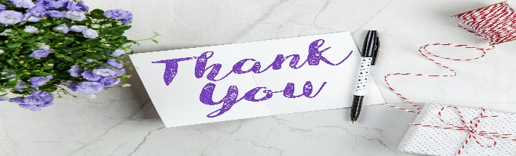

Thanks To all NP specialists for sharing your knowledge through zoom presentations!

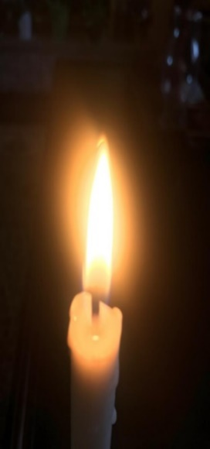
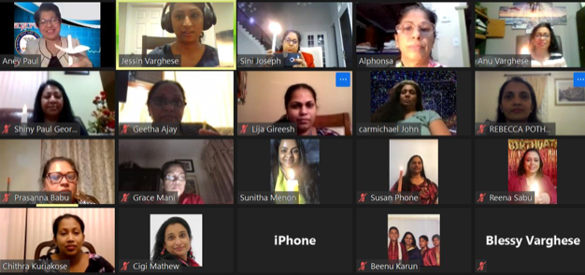
COVID-19 anniversary March 11th was observed as covid-19 anniversary. Members pray a moment of silence with Candlelight

REMEMBRANCE OF COVID ANNIVERSARY
REMEMBRANCE OF COVID ANNIVERSARY
PROUD TO BE A NURSE by Dr. Aney Paul, DNP, MSN, PNP, MPH

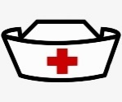
P
REMEMBRANCE OF COVID ANNIVERSARY

