National Indian Nurse Practitioners Association of America (NINPAA)
c/o 37 Etna Place, Nanuet, NY 10954
www.ninpaa.com
Newsletter Volume:3, Issue:1,2019
Executive Committee  President  Dr. Aney Paul , DNP, PNP, MPH  aneypaul@yahoo.com  Executive Vice President  Bridget George Parappurath, FNP  Vice President  Grace Mani, FNP  Secretary  Dr. Anu Varghese. DNP, FNP  anumedicostar@gmail.com  Joint Secretary  Dr. Cigi Mathew, DNP, FNP  Treasurer  Prasanna Babu, FNP  pbabumvk@yahoo.com  Joint Treasurer  Dr. Smitha Prasad, DNP, FNP  Committee Members  Chair, By-Laws  Rose Parangimalil, FNP  Chair, Professional Development/Education  Smitha Menon, FNP  Chair, Finance  Dr. Lija Gireesh, DNP, FNP  Chair, Membership  Dr. Susamma Abraham, DNP, FNP  Chair, Editorial Board  Tesmol James, FNP  Chair, Public relations  Beena Rajagopal, FNP  Chair, Awards & Scholarships  Dr. Kochurani Joseph, DNP, FNP  Chair, Social/Community Programs  Leena Alappatt, PNP  Chair, Election Committee  Mariamma Dubey, FNP  Directors-at-Large  Dr. Alphonsa Mathew, ANP (NY)  Dr. Padma Susan Mathew, DNP, FNP (TX)  Raji Mathew, FNP (DE)  Dr. Seline Jacob, DNP, FNP (NM)  Auditors  Sobha Panicker-Thomas, FNP  Stella Cherian FNP | President’s Message  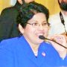  Greetings to all!  Nurse practitioners (NPs) can have a great positive impact on communities through patient advocacy and exceptional service delivery. Since the NP role was established in 1965, research has consistently demonstrated the excellent outcomes and high quality of care provided by NPs. The literature supports the position that NPs provide care that is safe, effective, patient centered, efficient, equitable and evidence based. I am grateful for the positive impacts NINPAA has made in the life Patients’ life.  NINPAA members along with other organizations volunteer in the community. NINPAA encourages networking at both state and national levels and strives to provide educational and professional development among its members. We had many successful activities: health fairs in different states, educational workshops in conference calls, discussion panels, mentoring NPs and nurses, helping NP students in finding clinical placements and helping NPs in finding jobs  We have WhatsApp group where there is always a discussion, Facebook page, website, and Newsletters. We had one Souvenir so far we will do another one next year. There is a big team working hard to make this association a great success.  I am thankful to the Executive Board, Directors-at-Large, Committee Chairs and Members, and to all those working hard to make our association successful I want to thank each one of you for your support and dedication.  Henry Ford said, "Coming together is a beginning, staying together is progress, and working together is success." As Henry Ford said, let us work together and make our Association a success.  Thank you,  Aney Paul, DNP, MSN, PNP, MPH  NINPAA, President

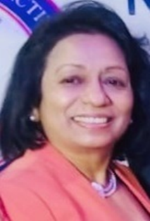
Secretary’s Corner

Nurse Practitioners have consistently been ranked as one of the top 5 best careers in the United States, thanks to its high marks in categories such as work-life balance, low-stress levels, and salary. Nurse practitioners are extremely valuable to the medical community and patients. NPs are also skilled at integrating health promotion, disease prevention, counseling, and education into patient visits to help individuals (and their families) better comprehend their healthcare issues. NINPAA promotes Indian American NPs to provide quality care to all patients. I am happy and proud to serve as the secretary for the National Indian Nurse practitioners Association of America. Thank you all for your support.
Anu Varghese, MSN, RN, DNP, FNP

Editorial Note
Working as a nurse practitioner is certainly inspiring and valuable. We can make a big difference in the life of a patient. NINPAA took the first steps in January 2016 and it’s making a difference in the life of patients. We are committed to educate the community and peers, lead the healthcare to a new dimension, innovate through technology, transform many lives, and empower like never before. NINPAA is writing this story to last a life time and let the meaning of this year’s echoes in each heart to make that ELITE change to touch many lives. We bear the torch to shine the light upon the hills to lead the path.
Tesmol James, APRN,FNP

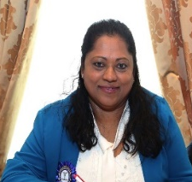
Treasurer’s Message
Nursing associations are organizations dedicated to the professional and personal growth of members and to the general advancement of the profession. Joining a professional nursing association is important due to the ever-changing field of nursing. Joining a professional association provides resources, information, and opportunities that might not be available otherwise. By joining NINPAA you become a part of group of nurse practitioners who is providing high levels of professional standards, to their careers and to their profession. We are very proud to support nurse practitioners and nurse practitioner students by providing educational and networking opportunities they need to be successful. Join today!
Prasanna Babu, APRN, FNP.
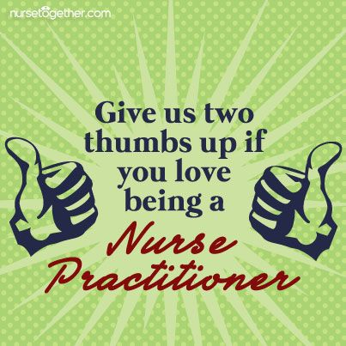

NP WEEK CELEBRATION 2018

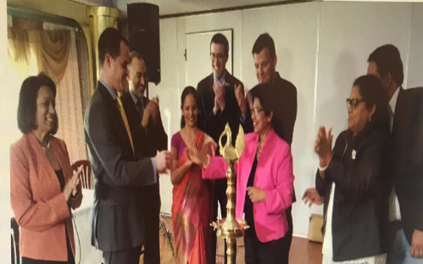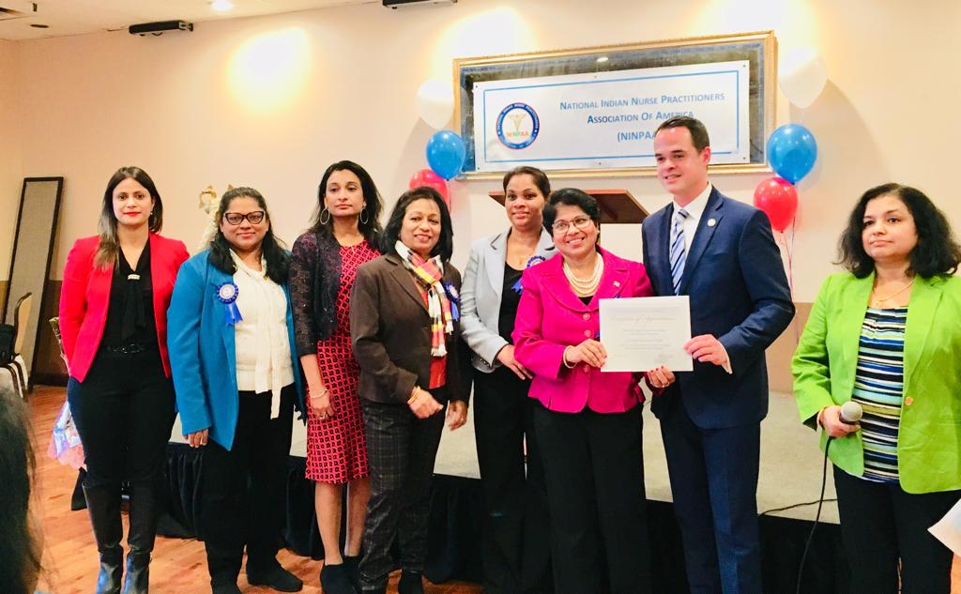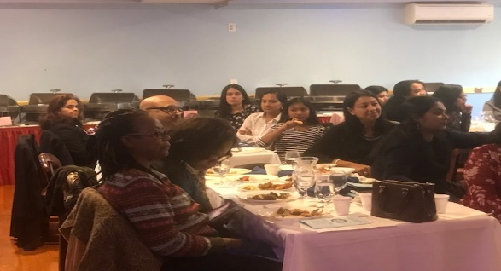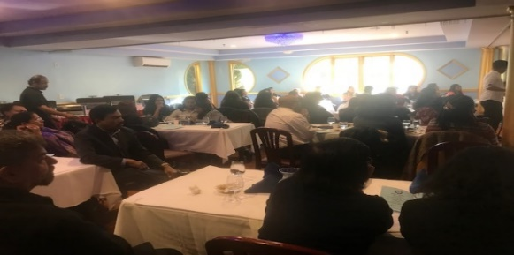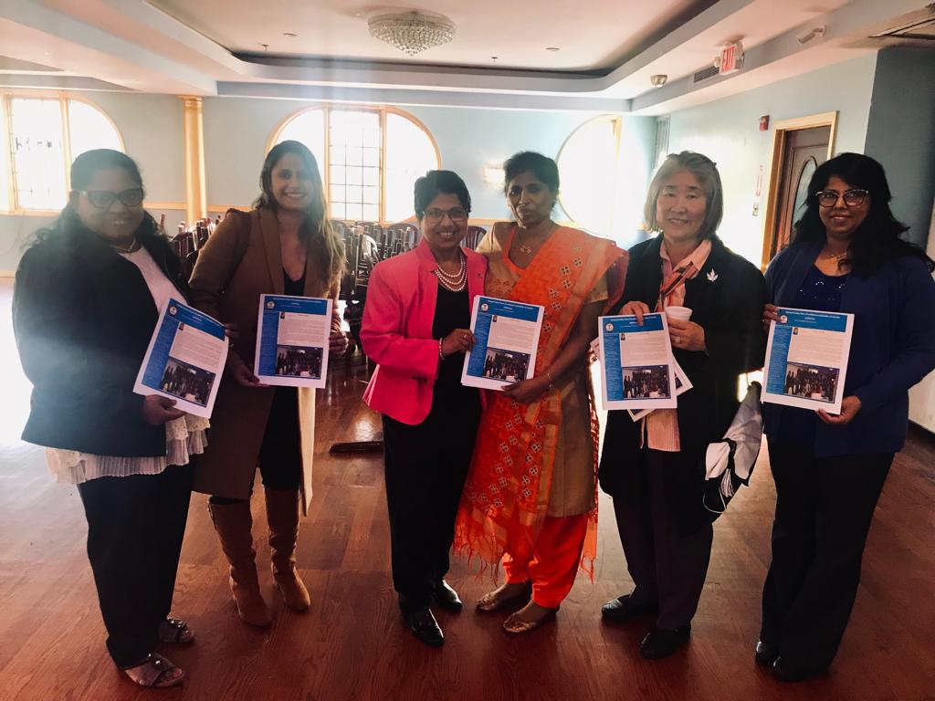

NINPAA celebrated the National NP week on November 10, 2018 at Saffron Indian Cuisine, Congers, New York from 11am to 3PM. The theme of the day was “NPs as Leaders”. Prominent Professional Leaders gave Keynote speech and politicians and NP legal advisors enriched the audience with new information and guidance. The day was indeed a very memorable day in the history of the NINPAA. NINPAA received proclamations from New York state and Rockland county legislature. Release of NINPAA’s 2nd Newsletter, Recognition of NP Service 15 and 10 years, Certificate of achievement to all new grad NPs, Awards to presenters and the guest speakers.
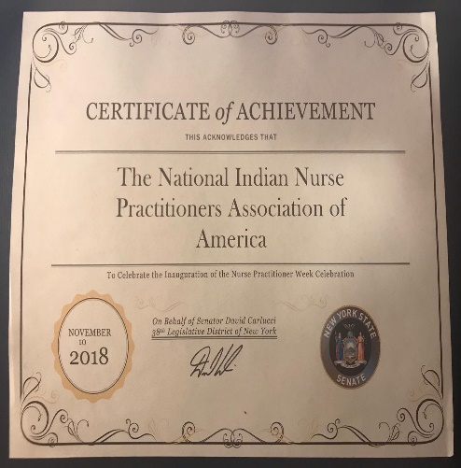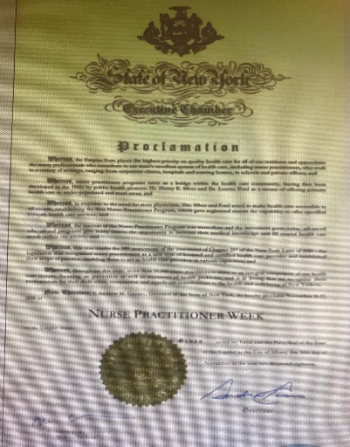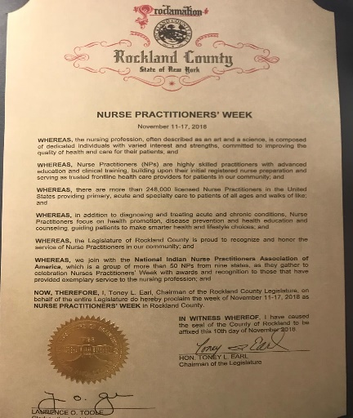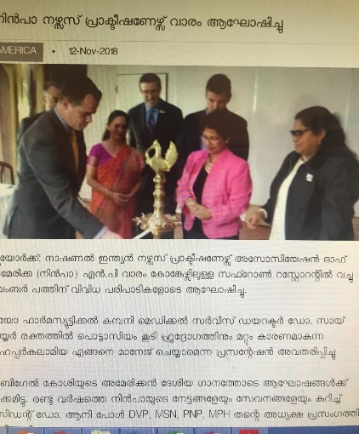

Steps to form a LLC (Limited Liability Company)
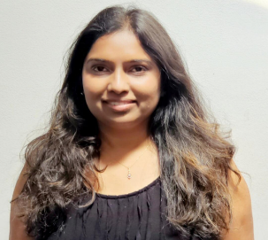Dr. Ann Meril, FNP-BC, NP-C, CEN, CCRNCEN Dr. ANN ME Dr. ANN MERIL, DNP, FNP
Steps to form a LLC (Limited Liability Company)

Steps to open a private medical practice

NINPAA NATIONAL CONFERENCE, 2019.
“Nursing Now: Excel, Lead and Innovate”

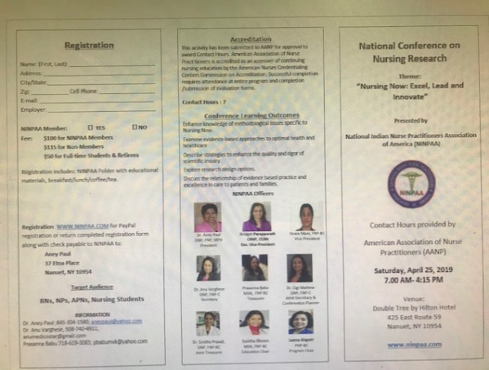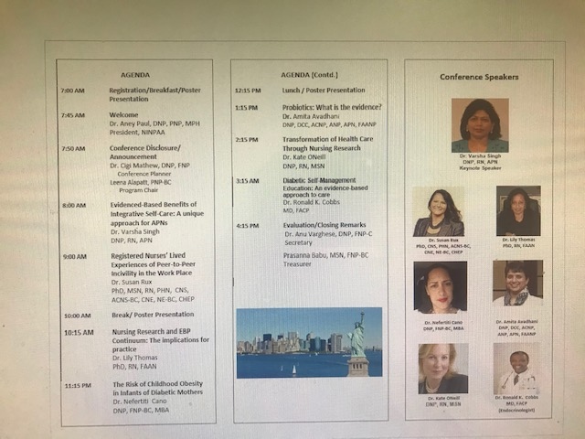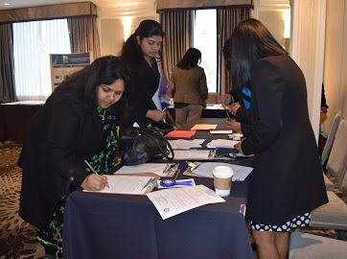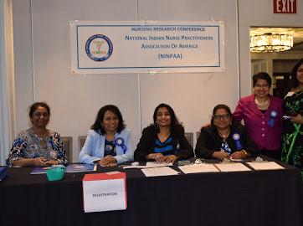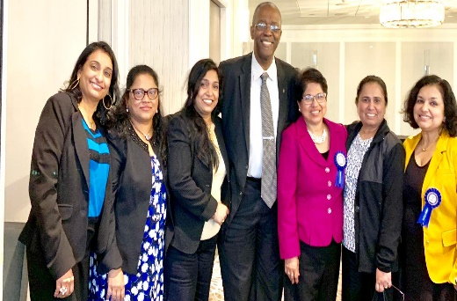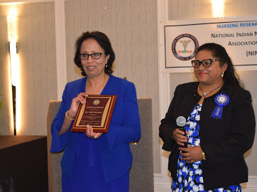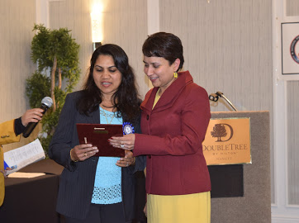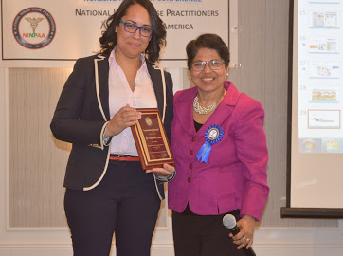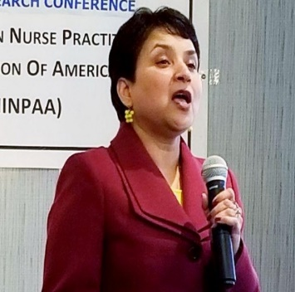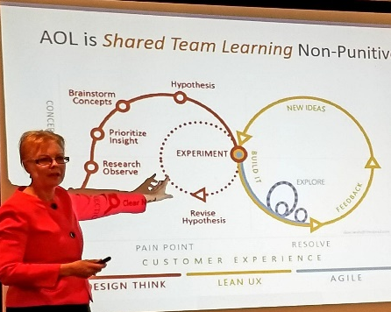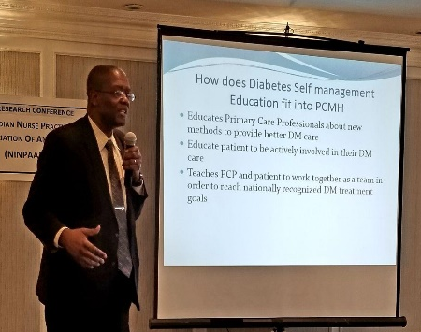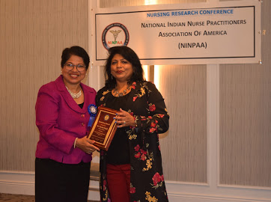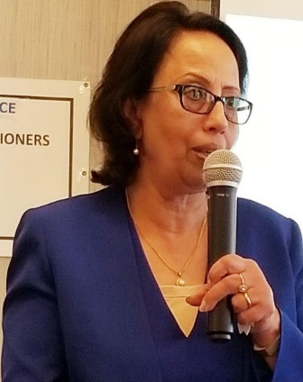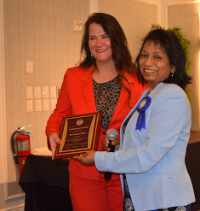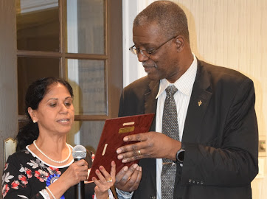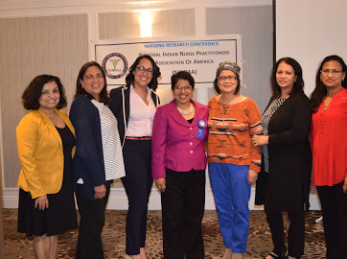

NATIONAL CONFERENCE, 2019 : THANKS TO SPONSORS
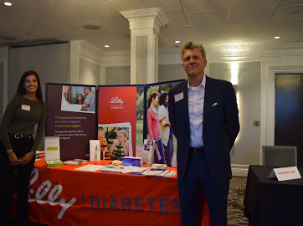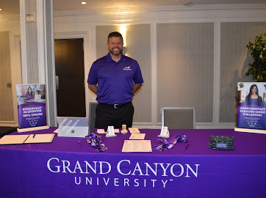
NATIONAL CONFERENCE, 2019: POSTER PRESENTATION 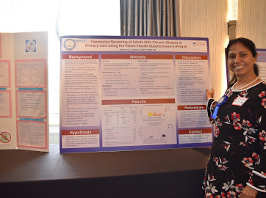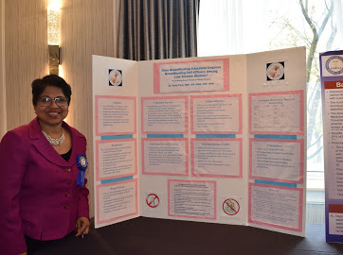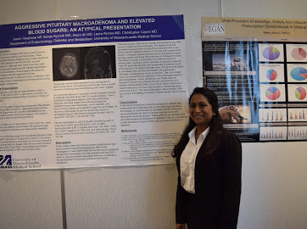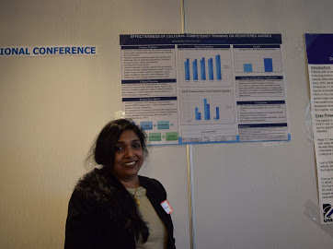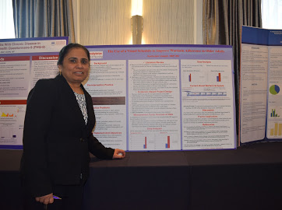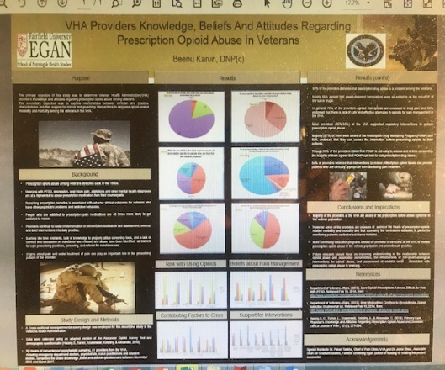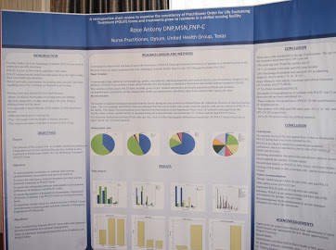 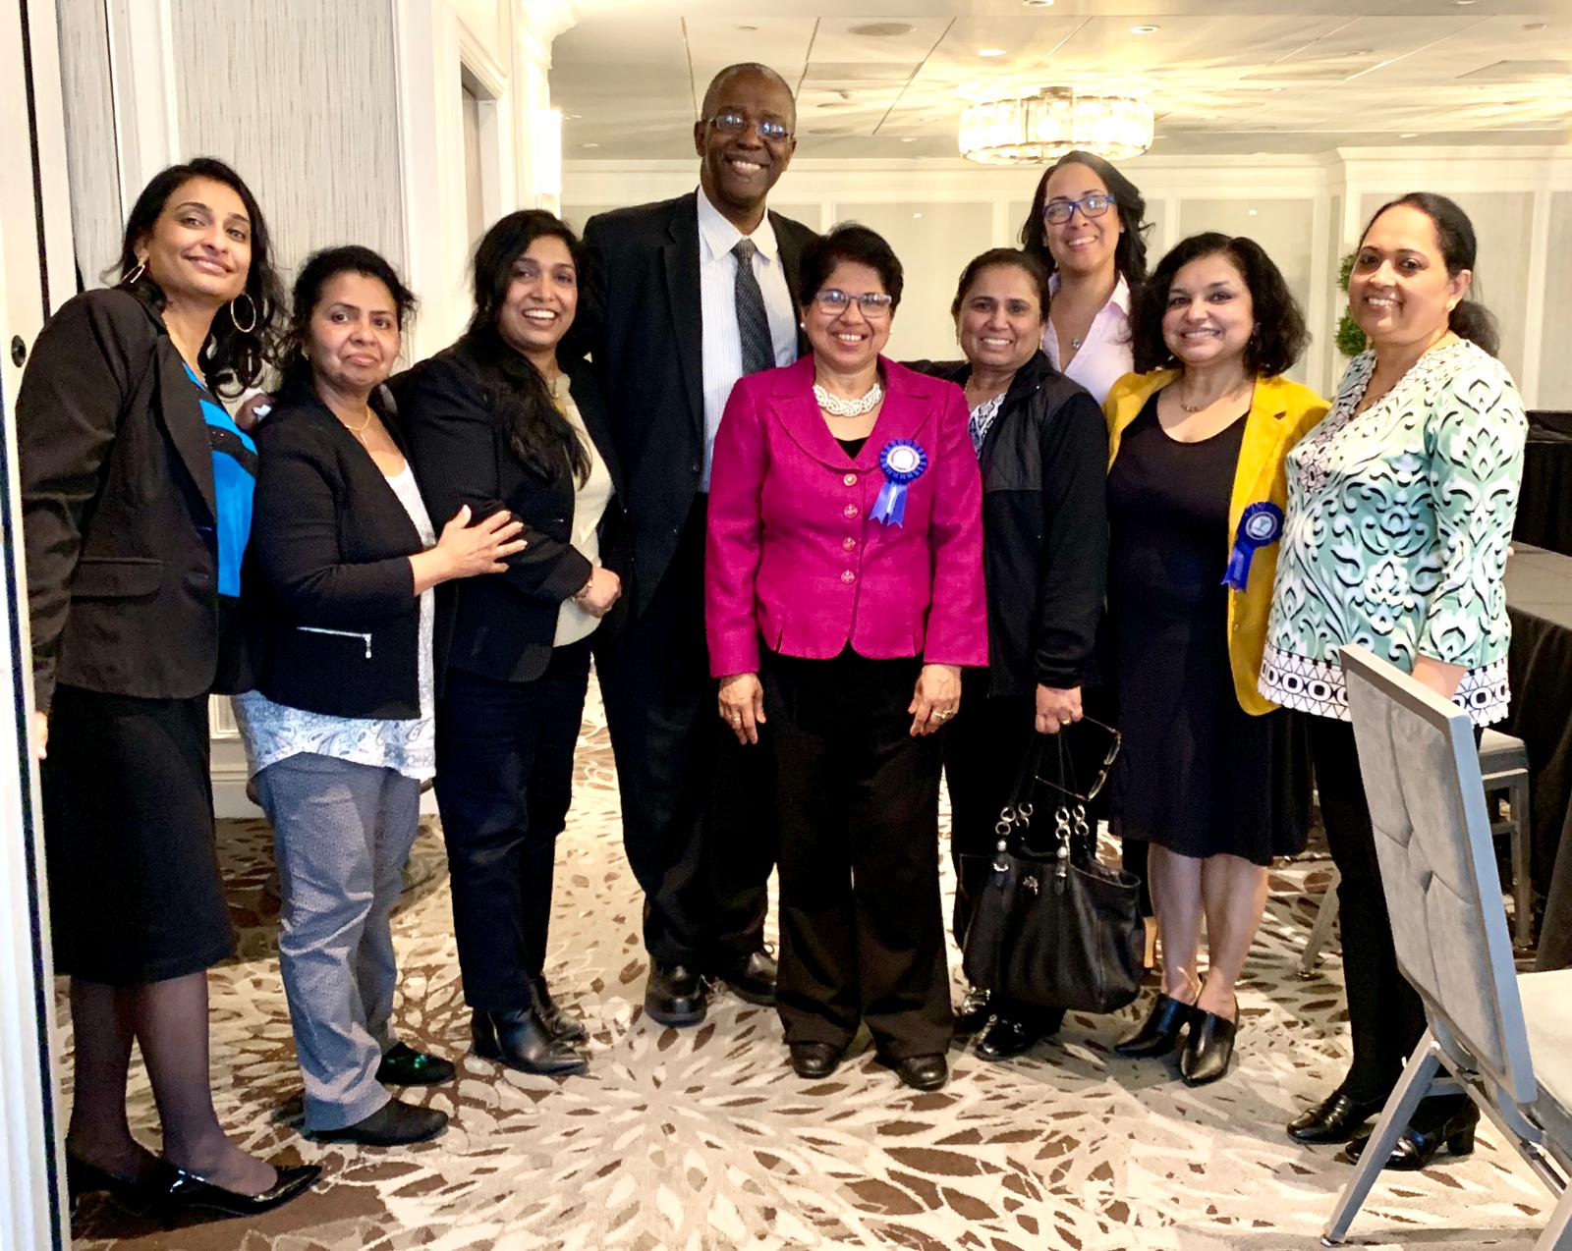
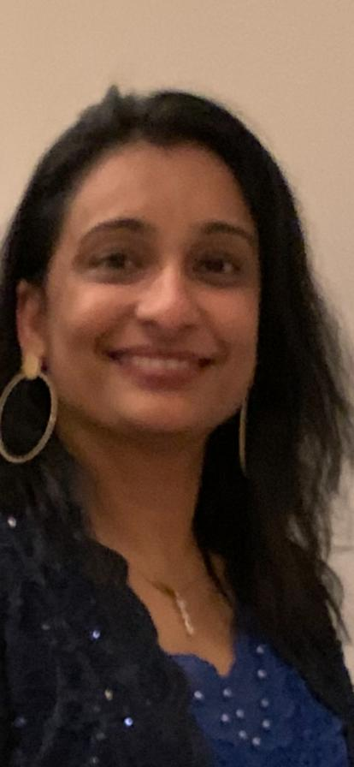
What is Sepsis?

DR. CIGI MATHEW, DNP, FN

What is Sepsis?
- Sepsis is a clinical syndrome that has physiologic, biologic, and biochemical abnormalities caused by a dysregulated inflammatory response to infection.
- It is a life-threatening medical emergency.
- Without timely treatment, sepsis can rapidly lead to tissue damage, organ failure, and death.
Significance
- Sepsis affects more than 1 million patients a year in the United States and even more patients around the global.
- Global rates of sepsis are as high as 437 per 100,000 person-year.
- sepsis appears to be responsible for 6 percent of US hospital admissions.
- It is one of the leading causes of death
- Sepsis has a high mortality rate
- mortality ranging from 30% to 50%
Etiology
- Many types of microbes can cause sepsis, including bacteria, fungi, and viruses.
- Bacteria are the most common cause
- In many cases, cannot identify the source of infection.
RISK FACTORS
- Anyone can get sepsis.
- The people at highest risk are infants, children, the elderly, and immunocompromised
- Previous hospitalizations: intensive care unit (ICU) admission, a nosocomial infection, bacteremia.
- Genetic factors
- Obesity

Excellence in Service Awards: Congratulations!

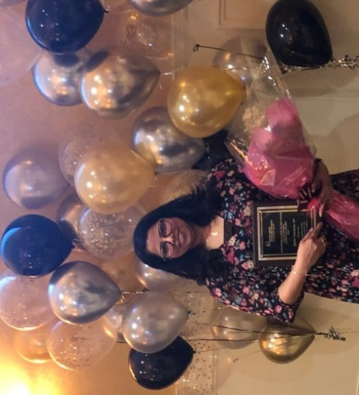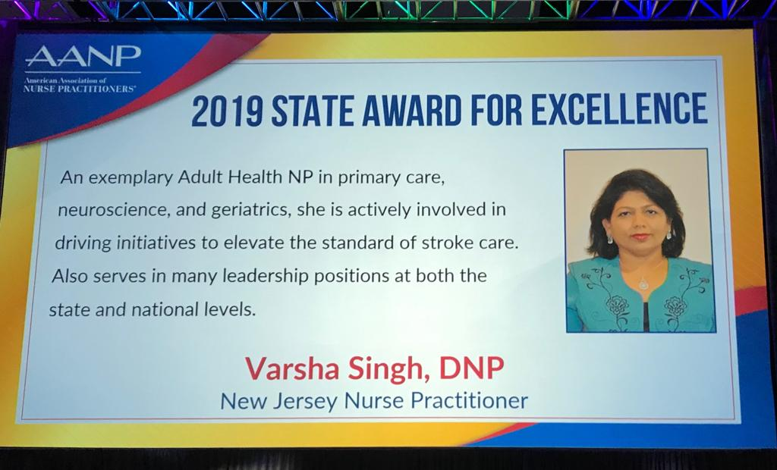
Stella Cheriyan, APRN,FNP Dr. Varsha Singh, DNP,FNP
NINPAA is a member of AANP. With NP Organization (NPO) Membership, NINPAA members receive an annual $10 discount on AANP membership.

. ,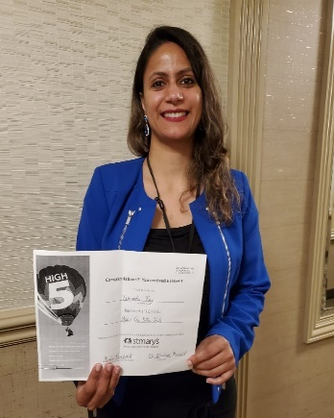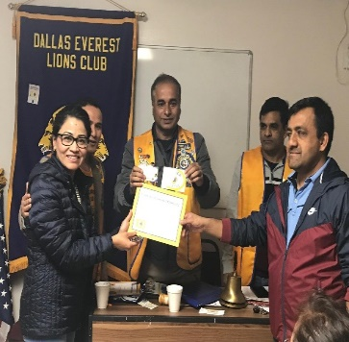

Vinita Roy,APRN,PNP: Dr. Maya Upadhey,DNP,FNP : Dr. Aney Paul,DNP,PNP

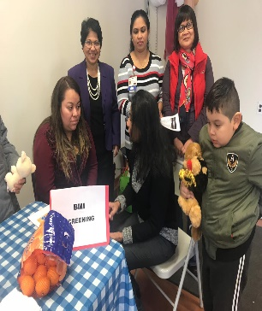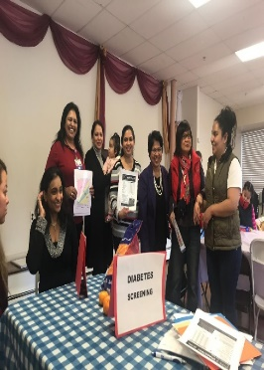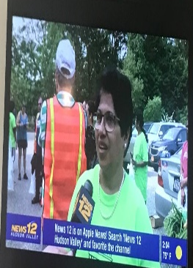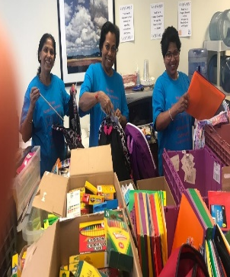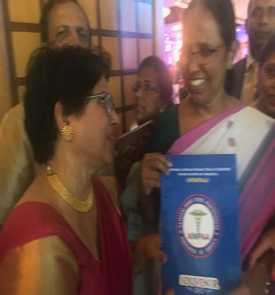
Health Fair in Rockland, NY NPs in the News Volunteering Presenting NINPAA souvenir
to Kerala Health Minister
- NINPAA: VISION
- The vision of the National Indian Nurse Practitioners Association of America (NINPAA) is to promote professional excellence, career advancement, and quality healthcare through leadership, education, and advocacy by Nurse Practitioners (NP).
- MISSION
- The mission of NINPAA is to facilitate and enable Indian American Nurse Practitioners of all specialties to ensure the best quality primary and specialty
health care to all. NINPAA encourages networking at the state and national level and strives to provide educational and professional development of its members.

President Dr. Aney Paul meeting members at different locations

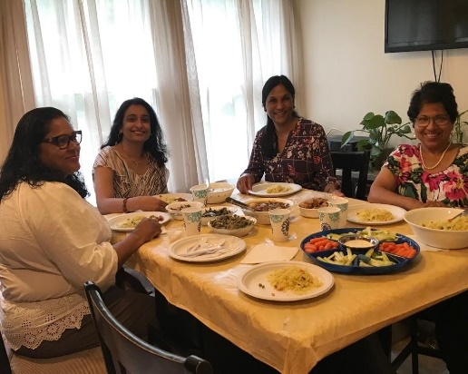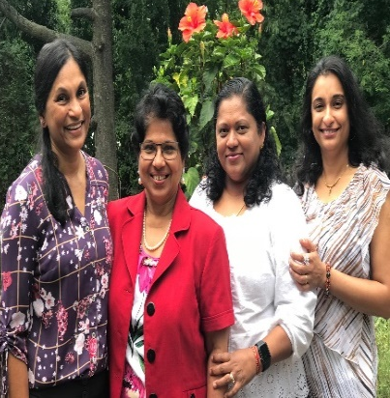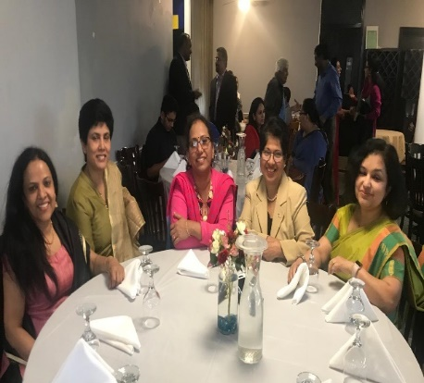
Members from NY, NJ meeting at President’s house Meeting members at Westchester, NY: Meeting at Boston
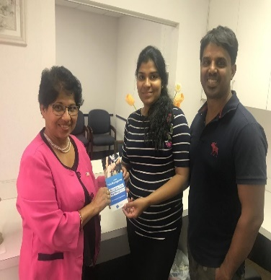
Rose Parangimalyl from Dallas , Dr. Shylla Roshen from Staten Island, NY, Chitra Kuiakose FNP met at Boston , Visiting Dr. Kripa Palppetta Owned clinic in CT.

NINPAA Historical Timeline

- Monthly Conference calls for planning started under the leadership Dr. Aney Paul in May 2015.
- Board of directors, Committees and directors at large were
- elected in October 2016
- NINPAA Vision and Mission finalized in February 2016.
- NNPAA was registered as a National organization in August 2016.
- NINPAA opened a bank account with Capital One Bank in October 2016.
NINPAA logo was designed and approved in November 2016.
- Membership form finalized November 2016
- First face to face committee meeting was held in NY on 12/3/2016.
- Bylaws completed 2017.
- NINPAA Website started 2017
- Inauguration of NINPAA as national organization on April 29, 2017 in NY
- Yearly NP week celebration in New York during the month of November
- Joint secretary and Joint treasurer were elected in February 2019.
- Received membership from American Academy of Nurse Practitioners in April, 2019.
- National Conference on Nursing research in April 2019

Poem
Sunshine
Dr. Aney Paul

It was a cool winter
I woke up early morning
I glanced through the window
Shining rays of sun rushed
Into my room, into my eyes
Into my hearts, made me happy
The sunshine keeps me happy
May the sunshine,
Shine upon your life
Today and tomorrow.

Scholarship and Charity donations
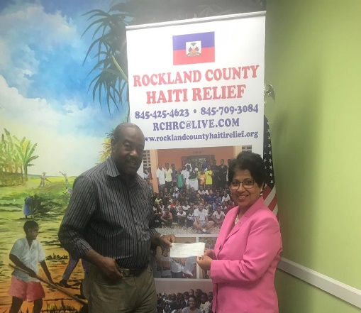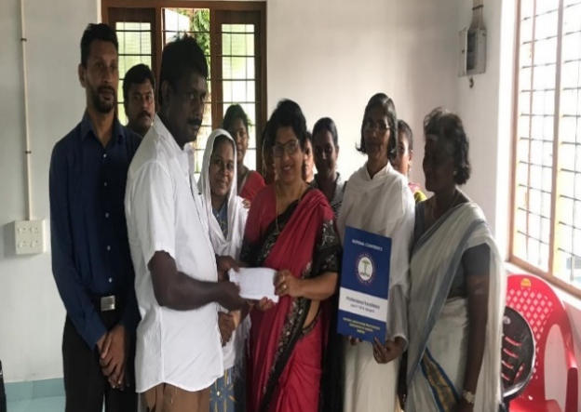
Scholarship presented in India by Flood Relief Donation NINPAA Donated money to TWSS to start
Vice President Bridget George.
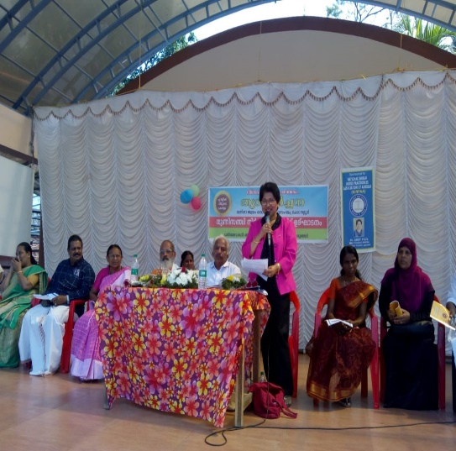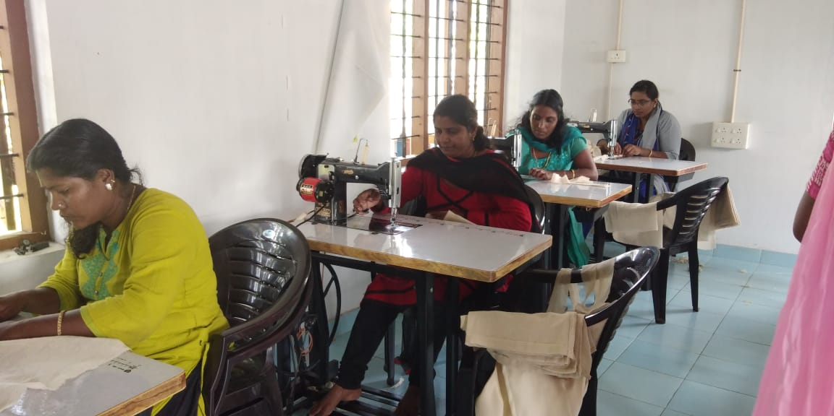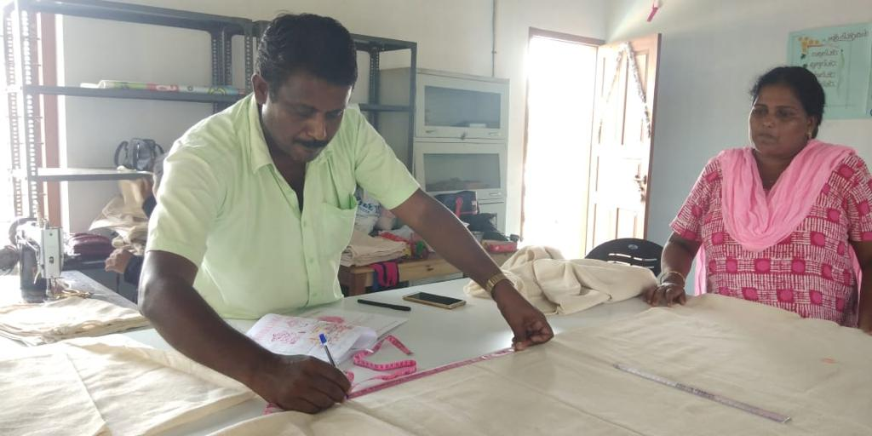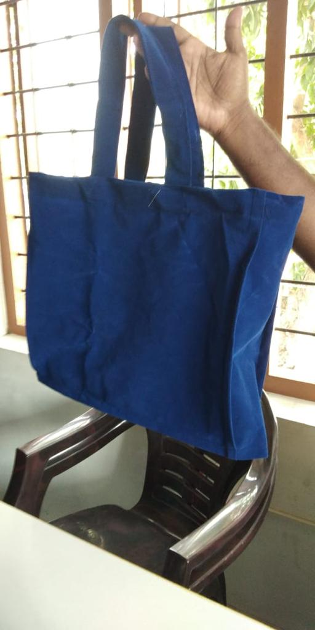
Sewing business for women who lost their homes in the flood.
Women's self-employment & Service Society' (TWSS) on 1st February 2019 at Cheranallur Panchayat Kochi, Kerala. Sri M R Antony, Block Panchayat President inaugurated Smt. Soni Chieku, Gram Panchayat President presided, Swami Sachhidanand Bharathi delivered the Benedictory address, Hon. Dr. Aney Paul, President NINPAA, USA was the Guest of Honor. The TWSS was sponsored by NINPAA (National Indian Nurse Practitioners Association of America).

NP Practice
Full practice: “State practice and licensure law provides for all nurse practitioners to evaluate patients, diagnose, order and interpret diagnostic tests, initiate and manage treatments—including prescribe medications under the exclusive licensure authority of the state Board of Nursing.”
Reduced practice: “State practice and licensure law reduces the ability of nurse practitioners to engage in
at least one element of NP practice. State law requires a regulated collaborative agreement with an outside
health discipline in order for the NP to provide patient care or limits the setting or scope of one or more
elements of NP practice.”
Restricted practice: “State practice and licensure law restricts the ability of a nurse practitioner to engage
in at least one element of NP practice. State requires supervision, delegation, or team-management by an
outside health discipline in order for the NP to provide patient care.”

“They Forget your name, but they will never forget how you made them feel “ Maya Angelo.

